EX. No: 1
Implement the functions using Math library
Date: 24.06.2026
Aim:
To write a Python program to perform mathematical operations using the Math library.
Code:
import math
print("1. Square Root\n2. Power\n3. Factorial\n4. Ceiling\n5. Floor\n6. Absolute Value\n7. GCD\n8. Sine\n9. Cosine\n10. Logarithm\n0. Exit")
while True:
try:
choice = int(input("Enter choice: "))
match choice:
case 0:
break
case 1:
value = float(input("Enter a non-negative number: "))
if value < 0:
print("Square root requires a non-negative number.")
else: print("Square Root:", math.sqrt(value))
case 2:
first = float(input("Enter base: "))
second = float(input("Enter exponent: "))
print("Power:", math.pow(first, second))
case 3:
value = int(input("Enter a non-negative integer: "))
if value < 0:
print("Factorial is not defined for negative integers.")
else:
print("Factorial:", math.factorial(value))
case 4:
value = float(input("Enter a number: "))
print("Ceiling:", math.ceil(value))
case 5:
value = float(input("Enter a number: "))
print("Floor:", math.floor(value))
case 6:
value = float(input("Enter a number: "))
print("Absolute value:", math.fabs(value))
case 7:
first = int(input("Enter first integer: "))
second = int(input("Enter second integer: "))
print("GCD:", math.gcd(first, second))
case 8:
angle = float(input("Enter angle in degrees: "))
print("Sine:", math.sin(math.radians(angle)))
case 9:
angle = float(input("Enter angle in degrees: "))
print("Cosine:", math.cos(math.radians(angle)))
case 10:
value = float(input("Enter a positive number: "))
if value <= 0:
print("Logarithm requires a positive number.")
else: print("Logarithm:", math.log(value))
case _:
print("Invalid choice. Select a listed option.")
except (ValueError) as error:
print("Invalid value:", error)

Output:
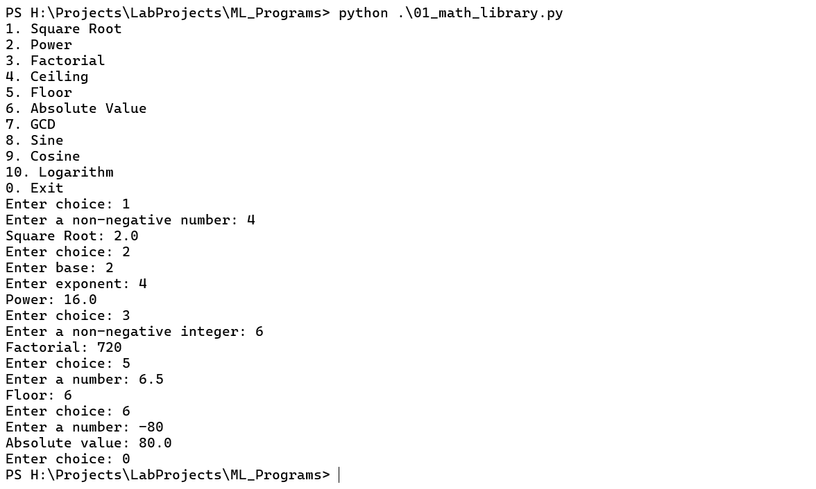

Result:
Thus, the above code is executed and the output verified successfully.
EX. No: 2
Create and manipulate multidimensional arrays using NumPy
Date: 30.06.2026
Aim:
To write a Python program to create and manipulate multidimensional arrays using the NumPy library.
Code:
import numpy as np
try:
ro = int(input("Enter the No of Rows: "))
co = int(input("Enter the No of Columns: "))
if ro <= 0 or co <= 0:
raise ValueError("Rows and columns must be positive.")
arr = np.zeros((ro, co), dtype=int)
def cre(arr, ro, co):
for i in range(ro):
for j in range(co):
arr[i, j] = int(input(f"Enter the Number [{i},{j}]: "))
return arr
def PrintArr(arr):
rows, cols = arr.shape
for i in range(rows):
for j in range(cols):
print(arr[i, j], end=" ")
print()
arr = cre(arr, ro, co)
while True:
try:
print("\nPress 1 for Display\nPress 2 for Transpose\nPress 3 for Min and Max\nPress 4 for Sum\nPress 5 for Row and Column Sum\nPress 6 for Diagonal Values\nPress 7 for Update\nPress 8 for Array Details\nPress 9 for Sub Array\nPress 10 for Matrix Addition and Subtraction\nPress 0 to Exit")
ch = int(input("Enter your Choice: "))
match ch:
case 1:
print("Array Elements are:")
PrintArr(arr)
case 2:
print("Transpose Array:")
PrintArr(arr.T)
case 3:
print(f"Minimum Element: {np.min(arr)}")
print(f"Maximum Element: {np.max(arr)}")
case 4:
print(f"Sum of Array: {np.sum(arr)}")
case 5:
print(f"Sum of Rows: {np.sum(arr, axis=1)}")
print(f"Sum of Columns: {np.sum(arr, axis=0)}")
case 6:
if ro == co:
print(f"Diagonal Values: {np.diag(arr)}")
else:
print("Row and column sizes are not the same.")
case 7:
r = int(input("Update Row Index: "))
c = int(input("Update Column Index: "))

if 0 <= r < ro and 0 <= c < co:
arr[r, c] = int(input("Enter New Element: "))
print("Element updated successfully!")
else:
print("Index out of bounds!")
case 8:
print(f"Array Size: {np.size(arr)}")
print(f"Array Dimensions: {np.ndim(arr)}")
print(f"Array Shape: {np.shape(arr)}")
case 9:
print(f"Row indices: 0 to {ro - 1}, Column indices: 0 to {co - 1}")
rs = int(input("Sub Array Row Start Index: "))
re = int(input("Sub Array Row End Index: "))
cs = int(input("Sub Array Column Start Index: "))
ce = int(input("Sub Array Column End Index: "))

if 0 <= rs <= re < ro and 0 <= cs <= ce < co:
subarray = arr[rs:re + 1, cs:ce + 1]
print("Extracted Sub Array:")
PrintArr(subarray)
else:
print("Invalid indices!")
case 10:
print("Enter Elements for Matrix 2:")
arr2 = cre(np.zeros((ro, co), dtype=int), ro, co)
print("Matrix Addition Result:")
PrintArr(arr + arr2)
print("Matrix Subtraction Result:")
PrintArr(arr - arr2)
case 0:
print("Exiting program. Goodbye!")
break
case _:
print("Invalid choice! Please try again.")
except (ValueError, IndexError) as e:
print("Invalid input:", e)
except Exception as e:
print("Error:", e)
except (ValueError, OverflowError) as e:
print("Invalid input:", e)
except Exception as e:
print("Error:", e)

Output:
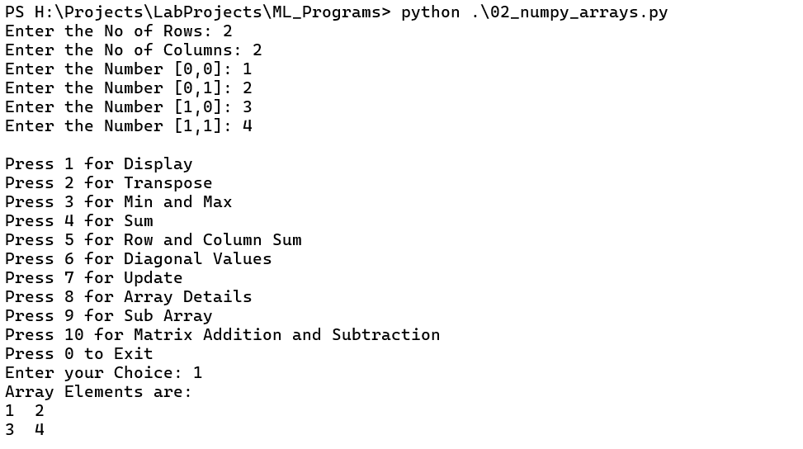
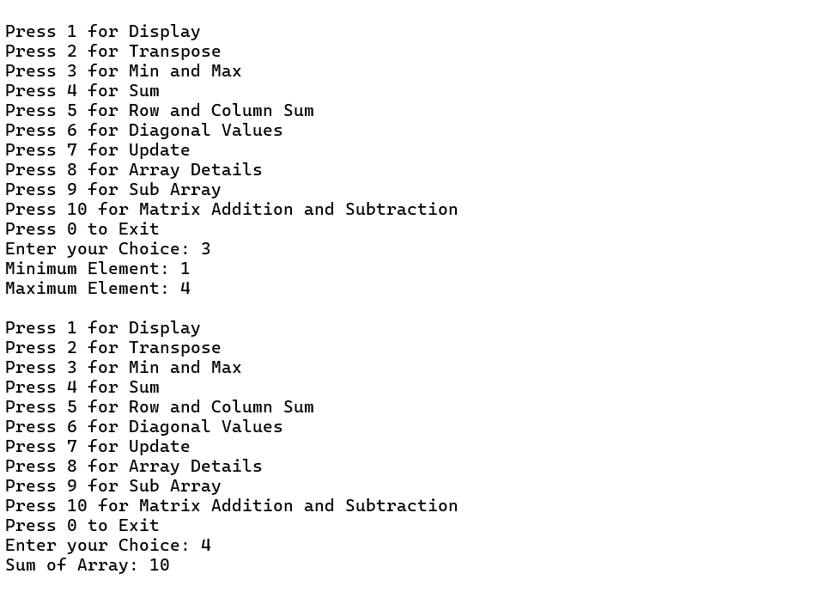

Result:
Thus, the above code is executed and the output verified successfully.
EX. No: 3
Perform statistical functions using Statistics library
Date: 04.07.2026
Aim:
To write a Python program to perform statistical operations using the Statistics library.
Code:
import statistics as st
print("\nPress 1 for Mean()\nPress 2 for Median()\nPress 3 for Mode()\nPress 4 for Standard Deviation\nPress 5 for Variance\nPress 6 for Harmonic Mean\nPress 7 for Median Low\nPress 8 for Median High\nPress 9 for Population Standard Deviation\nPress 10 for Population Variance\nPress 0 to Exit")
while True:
try:
choice = int(input("Enter your choice: "))
match choice:
case 0:
print("Program terminated.")
break
case 1:
data = list(map(float, input("Enter numbers separated by spaces: ").split()))
print("Mean:", st.mean(data))
case 2:
data = list(map(float, input("Enter numbers separated by spaces: ").split()))
print("Median:", st.median(data))
case 3:
data = list(map(float, input("Enter numbers separated by spaces: ").split()))
print("Mode:", st.mode(data))
case 4:
data = list(map(float, input("Enter numbers separated by spaces: ").split()))
print("Standard Deviation:", st.stdev(data))
case 5:
data = list(map(float, input("Enter numbers separated by spaces: ").split()))
print("Variance:", st.variance(data))
case 6:
data = list(map(float, input("Enter numbers separated by spaces: ").split()))
print("Harmonic Mean:", st.harmonic_mean(data))
case 7:
data = list(map(float, input("Enter numbers separated by spaces: ").split()))
print("Median Low:", st.median_low(data))
case 8:
data = list(map(float, input("Enter numbers separated by spaces: ").split()))
print("Median High:", st.median_high(data))
case 9:
data = list(map(float, input("Enter numbers separated by spaces: ").split()))
print("Population Standard Deviation:", st.pstdev(data))
case 10:
data = list(map(float, input("Enter numbers separated by spaces: ").split()))
print("Population Variance:", st.pvariance(data))
case _:
print("Invalid choice!")
except Exception as e:
print("Error:", e)
Output:
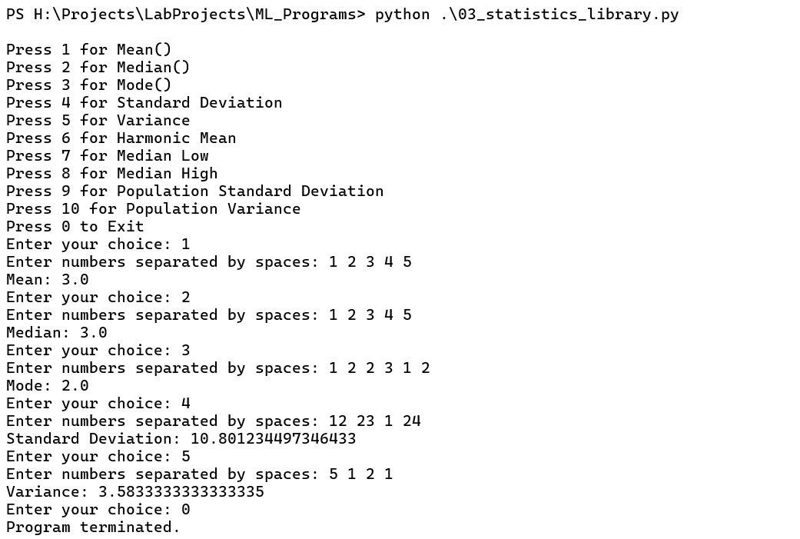
Result:
Thus, the above code is executed and the output verified successfully.
EX. No: 4
DataFrame implementation using Pandas
Date: 09.07.2026
Aim:
To write a Python program to create and manipulate DataFrames using the Pandas library.
Code:
import pandas as p
import numpy as np
print("\n1. Head Row\n2. Tail Row\n3. Specific Head and Tail Row\n4. Column Selection\n5. Add New Column\n6. Filter Data\n7. DataFrame Information\n8. Fillna\n9. Dropna\n10. IsNull and NotNull\n11. Replace\n12. Exit")
def Main():
n = int(input("Enter the number of Series: "))
name = []
episodes = []
year = []
for i in range(n):
print(f"---------- Enter Series {i+1} Details ----------")
na = input("Enter Series Name: ")
ep = int(input("Enter Episode Count: "))
yr = int(input("Enter Release Year: "))

name.append(na)
episodes.append(ep)
year.append(yr)
data = {
"Series Name": name,
"Episode Count": episodes,
"Release Year": year
}
df = p.DataFrame(data)
print("\n------------- DataFrame ---------------")
print(df)
Implement(df)

def Implement(df):
while True:
try:
ch = int(input("Enter Your Choice: "))
match ch:
case 1:
print("Head Row:\n", df.head())
case 2:
print("Tail Row:\n", df.tail())
case 3:
h = int(input("Enter the Number of Rows: "))
print("Head Row:\n", df.head(h))
print("Tail Row:\n", df.tail(h))
case 4:
print("All Columns:\n", df.columns)
s = input("Enter Specific Column: ")
print(df[s])
case 5:
ne = input("Enter the New Column Name: ")
da = []
for i in range(len(df)):
data = input("Enter the Data: ")
da.append(data)
df[ne] = da
print("New DataFrame:\n", df)
case 6:
ma = int(input("Enter the Minimum Episode Count: "))
print("Filtered Data:\n", df[df["Episode Count"] > ma])
case 7:
print("DataFrame Information:")
df.info()
print("DataFrame Description:\n", df.describe())
print("DataFrame Shape:", df.shape)
case 8:
print("Fillna:")
df["Episode Count"] = df["Episode Count"].fillna(df["Episode Count"].mean())
print(df["Episode Count"])
case 9:
print("Dropna:")
print(df["Episode Count"].dropna())
case 10:
print("IsNull:")
print(df.isnull())
print("NotNull:")
print(df.notnull())
case 11:
print("Replace:")
print(df["Episode Count"].replace(np.nan, 0))
case 12:
break
case _:
print("Invalid Choice!")
except Exception as e:
print("Error:", e)
try:
Main()
except Exception as e:
print("Error:", e)

Output:
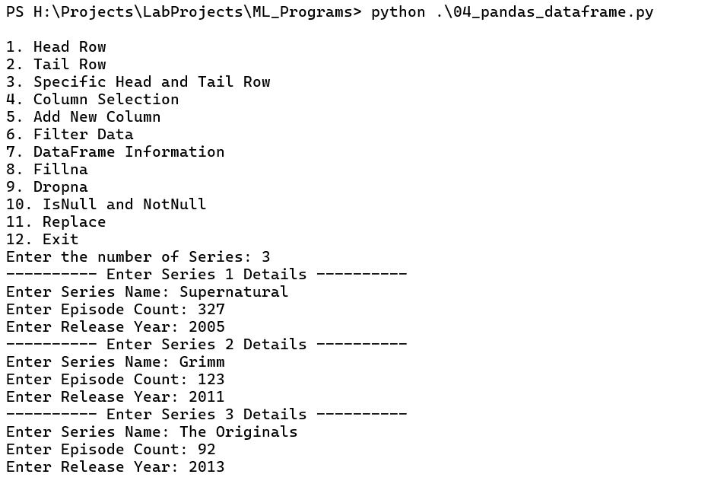
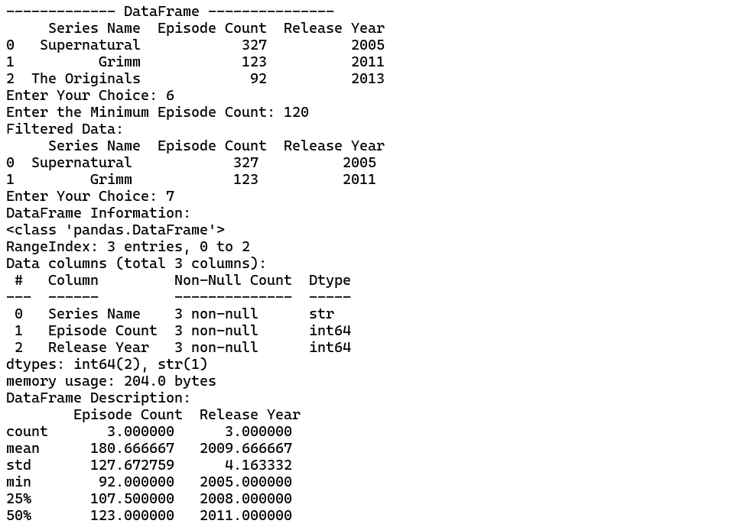

Result:
Thus, the above code is executed and the output verified successfully.
EX. No: 5
Handling the missing values in a dataset
Date: 13.07.2026
Aim:
To write a Python program to identify and handle missing values in a dataset using Pandas.
Code:
import pandas as p
import numpy as np
print("\n1. Fillna (Mean)\n2. DropNa\n3. IsNull and NotNull\n4. Replace Value\n5. Fillna (Median)\n6. Exit")
def CSV():
df = p.read_csv("datasets/handle_missing.csv")
Main(df)
def Main(df):
while True:
try:
ch = int(input("Enter Your Choice: "))
match ch:
case 1:
print("-------------- FillNa (Mean) --------------")
df["Episode Count"] = round(df["Episode Count"].fillna(df["Episode Count"].mean()), 2)
print("Mean To Fill Value:\n", df)
case 2:
print("-------------- DropNa --------------")
print(df["Episode Count"].dropna())
case 3:
print("-------------- IsNull --------------")
print(df.isnull())
print("-------------- NotNull --------------")
print(df.notnull())
case 4:
print("-------------- Replace --------------")
value = int(input("Enter the Replace Value: "))
print(df["Episode Count"].replace(np.nan, value))
case 5:
print("-------------- FillNa (Median) --------------")
df["Episode Count"] = round(df["Episode Count"].fillna(df["Episode Count"].median()), 2)
print("Median To Fill Value:\n", df)
case 6:
print("Program terminated.")
break
case _:
print("Invalid Choice!")
except Exception as e:
print("Error:", e)
try:
CSV()
except Exception as e:
print("Error:", e)

Output:
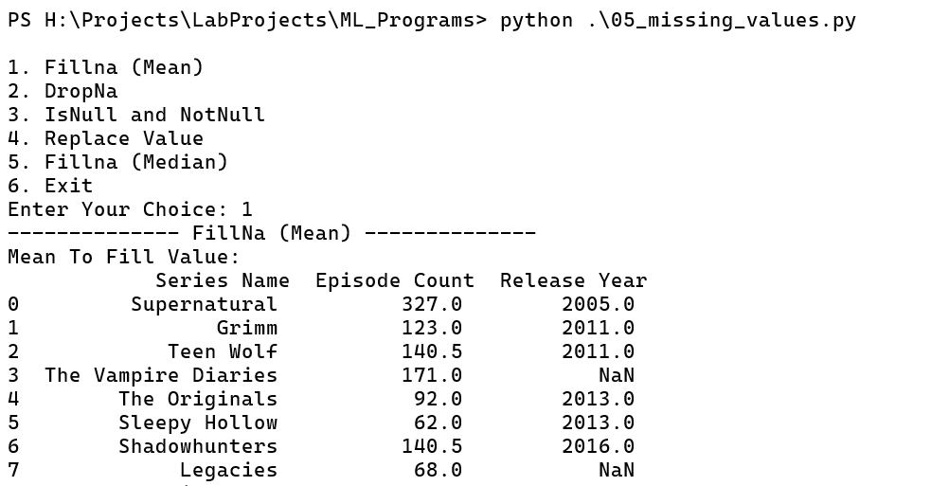

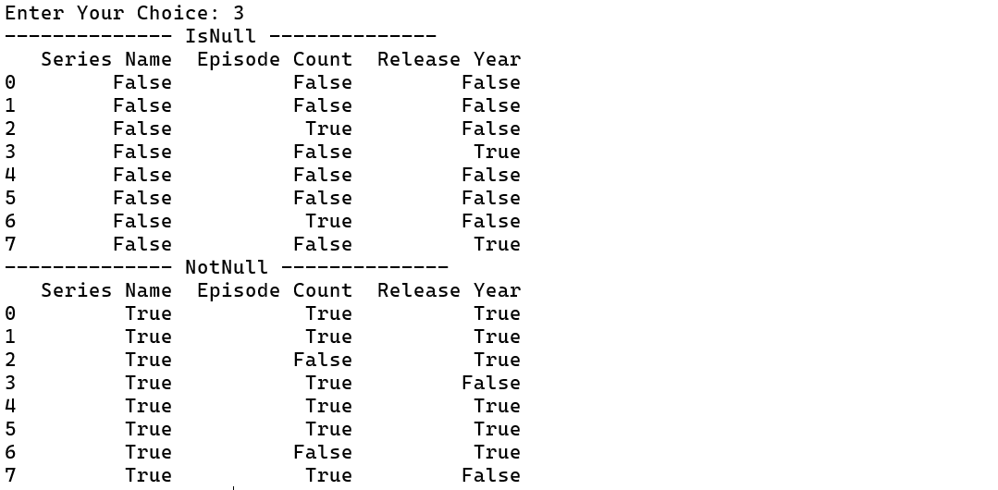
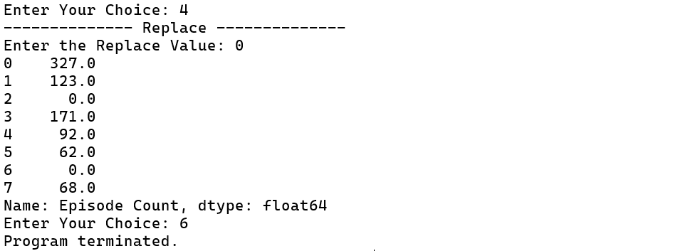

Result:
Thus, the above code is executed and the output verified successfully.
EX. No: 6
Load a dataset and perform the Data analysis
Date: 16.07.2026
Aim:
To write a Python program to load a dataset and perform data analysis using Pandas.
Code:
import pandas as pd
import numpy as np
data = pd.read_csv("datasets/zomato.csv")
# see the columns and type
print(data.dtypes)
# remove unwanted columns
data.drop(columns=["reviews_list"],inplace=True)
# drop rows where name is not present
data["name"].dropna()
# fill na values
data["votes"].fillna(0)
data["rate"].fillna("0/5")
for column in data.columns:
if column not in ["votes"]:
data[column].fillna("")
# remove duplicates
def getWithoutDuplicates(d):
return d.drop_duplicates(subset="name",keep="first")
# convert rate to float
def changeRate(d):
if d in ["NEW","-"]:
return 0
rate = str(d).split("/")[0]
return float(rate)
data["rate"] = data["rate"].apply(changeRate)
data["rate"] = pd.to_numeric(data["rate"],errors="coerce")
# Important ColumnsimpColumns = ["address","name","online_order","book_table","rate","location","cuisines","rest_type","dish_liked"]
gropuedColumns = ["name","rate"]
# Data analysis
# 1. Top Rated resturaents in each location
grouped_data = data.groupby("location")
for group in grouped_data.groups:
print(f"\tLocation: {group}")
grouped = grouped_data.get_group(group)
sorted_data = grouped.sort_values(by="rate",ascending=False,na_position="last")
sorted_data = getWithoutDuplicates(sorted_data)
sorted_data = sorted_data.head(3)
print(sorted_data[gropuedColumns])
# 2 Count How many online and offline orders
totalCount = len(data)
onlineCount = 0
offlineCount = 0
def countOrder(d):
if d.lower() == "yes":
global onlineCount
onlineCount += 1
else:
global offlineCount
offlineCount += 1
data["online_order"].apply(countOrder)
print(f"Online Orders: {onlineCount}/{totalCount}")
print(f"Offline Orders: {offlineCount}/{totalCount}")
#3 Total Resturants and total by resturants type
resturantsData = getWithoutDuplicates(data)
print(f"Total Resturants: {len(resturantsData)}")
groupByRestType = resturantsData.groupby("rest_type")
for restGroup in groupByRestType.groups:
currentGroupCount = groupByRestType.get_group(restGroup)["rest_type"].count()
print(f"Resturant Type: {restGroup} = {currentGroupCount}")
#4 Average rating by restaurant type
avg_rating = resturantsData.groupby("rest_type")["rate"].mean().sort_values(ascending=False)
print("Average Rating by Restaurant Type:")
print(avg_rating.head(10))
Output:
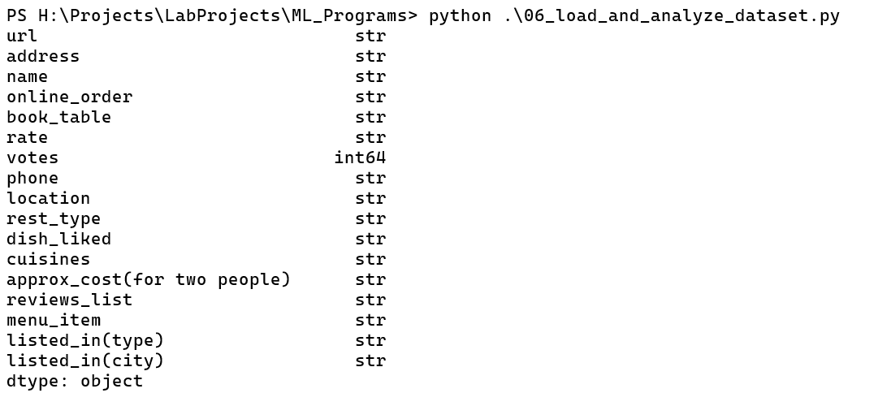
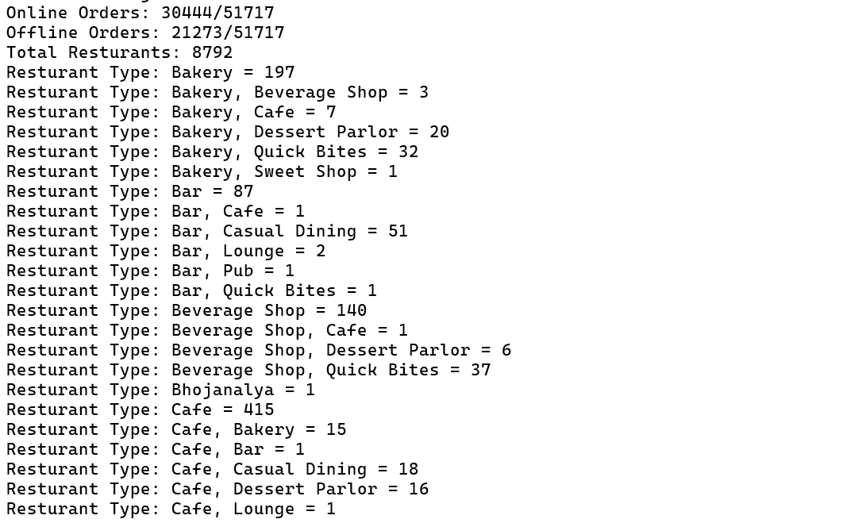
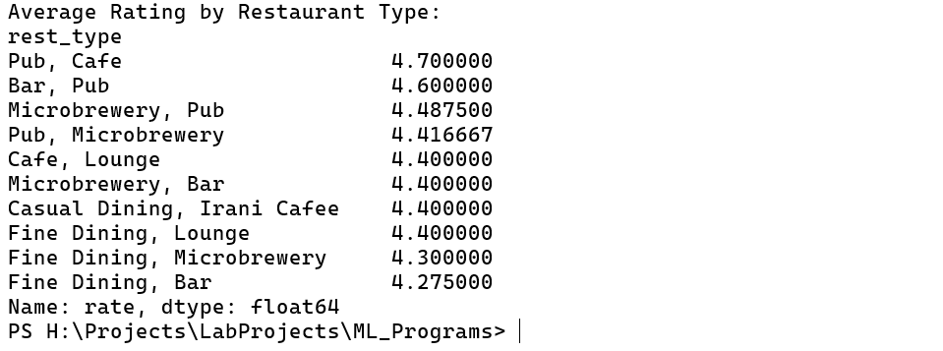
Result:
Thus, the above code is executed and the output verified successfully.
EX. No: 7
Load a dataset and display its structure with Statistical summaries using Pandas
Date: 21.07.2026
Aim:
To write a Python program to load a dataset and display its structure and statistical summaries using Pandas.
Code:
import pandas as pd
data = pd.read_csv("datasets/DataSet.csv")
print("\n1. Display Dataset Structure\n2. Display Statistical Summary\n3. Particular Column Summary\n4. Group Characters by Series\n5. Group Characters by Character Type\n6. Group by First Appearance Year\n7. Series and Character Type\n8. Exit")
while True:
try:
ch = int(input("Enter Your Choice: "))
match ch:
case 1:
print("\n\tDataset Structure")
print(data)
print("\n\tFirst Five Characters")
print(data.head())
print("\n\tLast Five Characters")
print(data.tail())
print("\nDataset Shape:", data.shape)
print("\nColumn Names:", data.columns)
print("\nData Types:\n", data.dtypes)
print("\nDataset Information:")
data.info()
print("\nMissing Values:\n", data.isnull().sum())
case 2:
print("\n\tStatistical Summary")
print(data.describe(include="all"))
case 3:
print("\nAvailable Columns:\n", data.columns)
col = input("Enter the Column Name: ")
print("\n\tColumn Summary")
print(data[col].describe())
case 4:
print("\n\tCharacters Grouped by Series")
print(data.groupby("Series")["Character Name"].apply(list))
case 5:
print("\n\tCharacters Grouped by Character Type")
print(data.groupby("Character Type")["Character Name"].apply(list))
case 6:
print("\n\tCharacters by First Appearance Year")
print(data.groupby("First Appearance Year")["Character Name"].apply(list))
case 7:
print("\n\tSeries and Character Type")
print(data.groupby(["Series", "Character Type"]).size())
case 8:
print("Program terminated.")
break
case _: print("Invalid Choice!")
except Exception as e:
print("Error:", e)
Output:
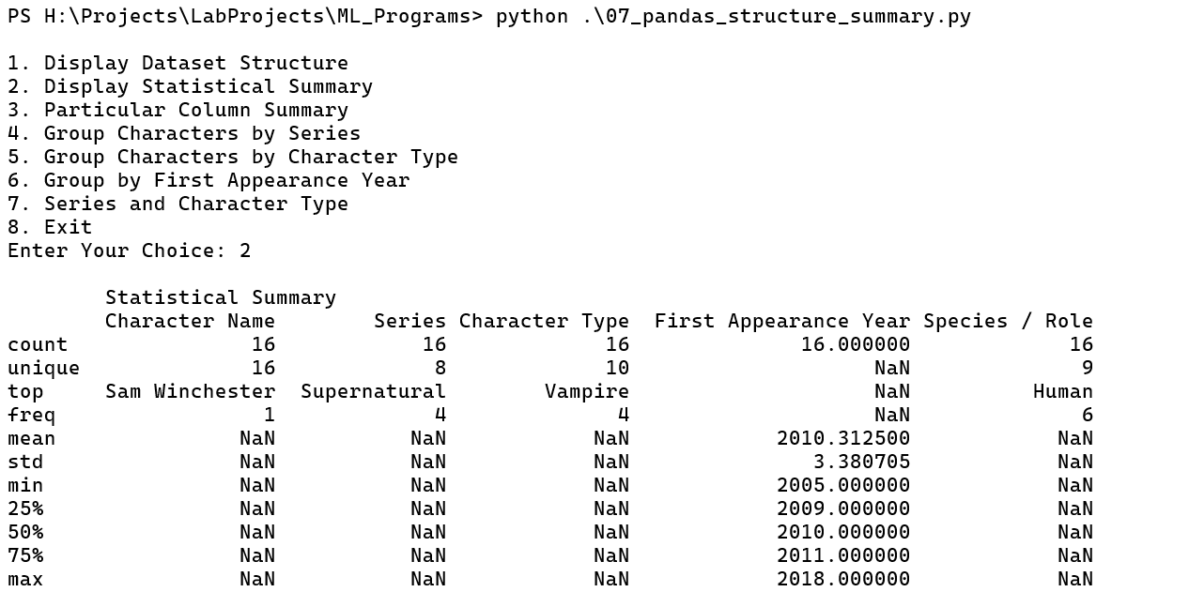
Result:
Thus, the above code is executed and the output verified successfully.
EX. No: 8
Load a dataset and display its structure with graphs using Pandas and Matplotlib
Date: 25.07.2026
Aim:
To write a Python program to load a dataset and visualize its structure using Pandas and Matplotlib.
Code:
import pandas as pd
import matplotlib.pyplot as plt
data = pd.read_csv("datasets/DataSet.csv")
print("\n1. Display Dataset Structure\n2. Display Statistical Summary\n3. Characters by Series (Bar Graph)\n4. Characters by Character Type (Bar Graph)\n5. First Appearance Year (Line Graph)\n6. Series Distribution (Pie Chart)\n7. Exit")
while True:
try:
ch = int(input("Enter Your Choice: "))
match ch:
case 1:
print("\n\tDataset Structure")
print(data)
print("\n\tFirst Five Characters")
print(data.head())
print("\n\tLast Five Characters")
print(data.tail())
print("\nDataset Shape:", data.shape)
print("\nColumn Names:", data.columns)
print("\nData Types:\n", data.dtypes)
print("\nDataset Information:")
data.info()
print("\nMissing Values:\n", data.isnull().sum())
case 2:
print("\n\tStatistical Summary")
print(data.describe(include="all"))
case 3:
print("\n\tCharacters by Series")
counts = data["Series"].value_counts()
print(counts)
counts.plot(kind="bar", title="Characters by Series")
plt.xlabel("Series")
plt.ylabel("Number of Characters")
plt.xticks(rotation=45, ha="right")
plt.tight_layout()
plt.show()
case 4:
print("\n\tCharacters by Character Type")
counts = data["Character Type"].value_counts()
print(counts)
counts.plot(kind="bar", title="Characters by Type")
plt.xlabel("Character Type")
plt.ylabel("Number of Characters")
plt.xticks(rotation=45, ha="right")
plt.tight_layout()
plt.show()
case 5:
print("\n\tCharacters by First Appearance Year")
counts = data["First Appearance Year"].value_counts().sort_index()
print(counts)
counts.plot(kind="line", marker="o", title="Characters by First Appearance Year")
plt.xlabel("First Appearance Year")
plt.ylabel("Number of Characters")
plt.grid(True)
plt.tight_layout()
plt.show()
case 6:
print("\n\tSeries Distribution")
counts = data["Series"].value_counts()
print(counts)
counts.plot(kind="pie", autopct="%1.1f%%", title="Series Distribution")
plt.ylabel("")
plt.tight_layout()
plt.show()
case 7:
print("Program terminated.")
break
case _:
print("Invalid Choice!")
except Exception as e:
print("Error:", e)
Output:
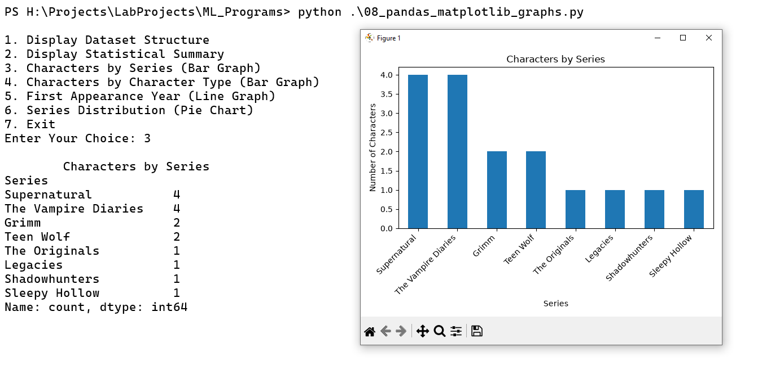
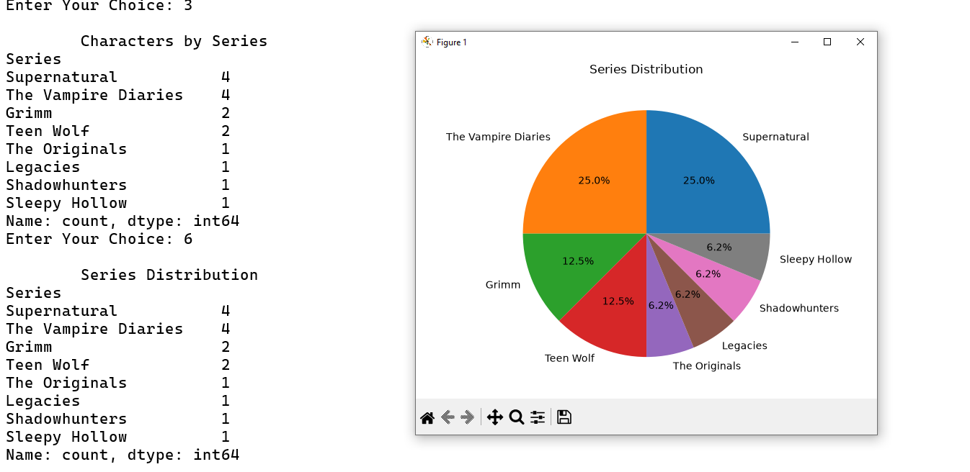

Result:
Thus, the above code is executed and the output verified successfully.
EX. No: 9
Perform Visualization using Seaborn
Date: 30.07.2026
Aim:
To write a Python program to visualize a dataset using the Seaborn library.
Code:
import pandas as pd
import seaborn as sns
import matplotlib.pyplot as plt
data = pd.read_csv("datasets/Ben10Dataset.csv")
print("\n1. Display Dataset\n2. Scatter Plot\n3. Histogram\n4. Box Plot\n5. Heatmap\n6. Violin Plot\n7. Count Plot\n8. Pair Plot\n0. Exit")
while True:
try:
ch = int(input("Enter Your Choice: "))
match ch:
case 1:
print("\n---------- Ben 10 Alien Dataset ----------")
print(data.head(5))
case 2:
print("\n---------- Scatter Plot ----------")
sns.scatterplot(data=data, x="Height (m)", y="Power Level", hue="Series")
plt.title("Alien Height vs Power Level")
plt.show()
case 3:
print("\n---------- Histogram ----------")
sns.histplot(data=data, x="Power Level", bins=8, kde=True)
plt.title("Distribution of Alien Power Levels")
plt.show()
case 4:
print("\n---------- Box Plot ----------")
sns.boxplot(data=data, x="Series", y="Height (m)")
plt.title("Alien Height by Series")
plt.xticks(rotation=30)
plt.tight_layout()
plt.show()
case 5:
print("\n---------- Heatmap ----------")
corr = data[["Power Level", "Height (m)", "First Appearance Year"]].corr()
sns.heatmap(corr, annot=True, cmap="coolwarm")
plt.title("Alien Dataset Correlation Heatmap")
plt.show()
case 6:
print("\n---------- Violin Plot ----------")
sns.violinplot(data=data, x="Series", y="Power Level")
plt.title("Power Level Distribution by Series")
plt.xticks(rotation=30)
plt.tight_layout()
plt.show()
case 7:
print("\n---------- Count Plot ----------")
sns.countplot(data=data, x="Element")
plt.title("Number of Aliens by Element")
plt.xticks(rotation=45)
plt.tight_layout()
plt.show()
case 8:
print("\n---------- Pair Plot ----------")
sns.pairplot(data, vars=["Power Level", "Height (m)", "First Appearance Year"], hue="Series")
plt.show()
case 0:
print("Program terminated.")
break
case _:
print("Invalid Choice!")
except Exception as e:
print("Error:", e)

Output:
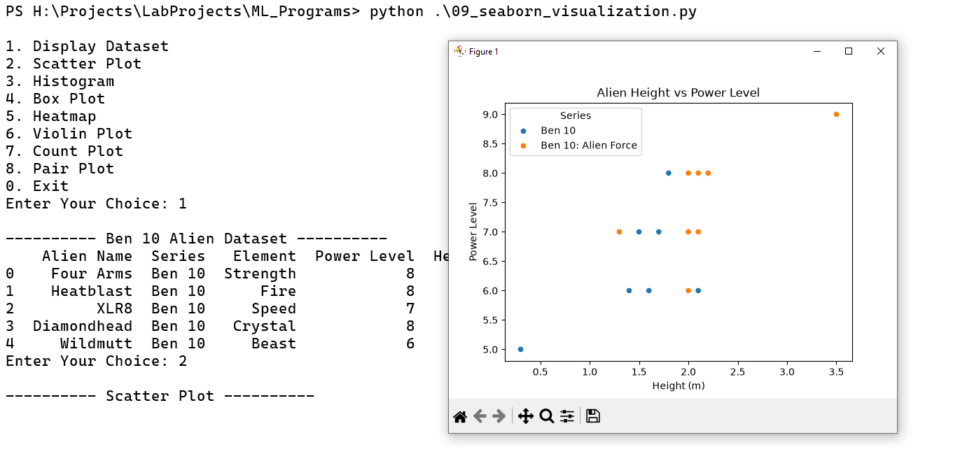
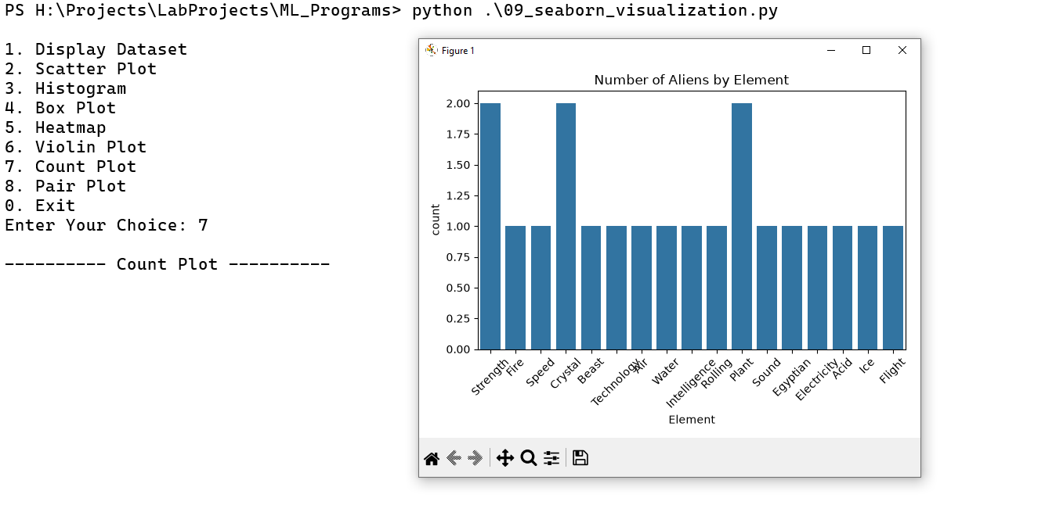

Result:
Thus, the dataset is visualized successfully using the Seaborn library.

EX. No: 10
Implementation of Covariance and Correlation
Date: 03.08.2026
Aim:
To write a Python program to calculate covariance and correlation between variables in a dataset.
Code:
def covariance(x, y):
n = len(x)
mean_x = sum(x) / n
mean_y = sum(y) / n
total = 0
for i in range(n):
total += (x[i] - mean_x) * (y[i] - mean_y)
return total / (n - 1)
def correlation(x, y):
n = len(x)
mean_x = sum(x) / n
mean_y = sum(y) / n
numerator = 0
sum_x = 0
sum_y = 0
for i in range(n):
dx = x[i] - mean_x
dy = y[i] - mean_y
numerator += dx * dy
sum_x += dx ** 2
sum_y += dy ** 2
denominator = (sum_x * sum_y) ** 0.5
if denominator == 0:
return "Correlation cannot be calculated"
return numerator / denominator
n = int(input("Enter number of data points: "))
x = []
y = []
for i in range(n):
x.append(float(input("Enter X value: ")))
y.append(float(input("Enter Y value: ")))
print("\n--- MENU ---")
print("1. Display Data")
print("2. Covariance")
print("3. Correlation")
print("0. Exit")
while True:
ch = int(input("Enter your choice: "))
if ch == 1:
print("X =", x)
print("Y =", y)
elif ch == 2:
if n < 2:
print("Enter at least 2 data points")
else:
print("Covariance =", covariance(x, y))
elif ch == 3:
if n < 2:
print("Enter at least 2 data points")
else:
print("Correlation =", correlation(x, y))
elif ch == 0:
print("Program terminated.")
break
else:
print("Invalid choice!")

Output:
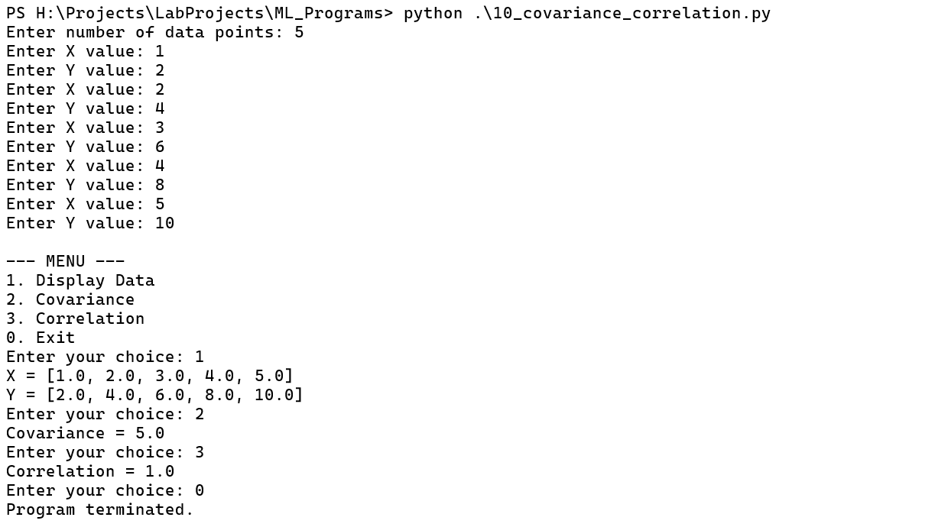

Result:
Thus, the above code is executed and the output verified successfully.
EX. No: 11
Perform Normalization in a given dataset
Date: 06.08.2026
Aim:
To write a Python program to normalize the values in a given dataset using appropriate normalization techniques.
Code:
import pandas as pd
import numpy as np
from scipy import stats
from sklearn.preprocessing import MinMaxScaler

df = pd.read_csv("datasets/Ben10Dataset.csv")
def MinMax(val, min, max, nmin, nmax):
if min == max:
return "Normalization cannot be calculated."
result = (((val - min) / (max - min)) * (nmax - nmin)) + nmin
return f"{val} ====> {np.round(result, 2)}"
def ZScore(val, mean, std):
if std == 0:
return "Z-Score cannot be calculated."
result = (val - mean) / std
return f"{val} ====> {round(result, 2)}"
def decimal(val):
dig = len(str(abs(int(val))))
return val / 10**dig
num = df.describe().columns.to_list()
print("\n1. MinMax Normalization\n2. Z-Score Normalization\n3. Decimal Scale Normalization\n4. Exit")
while True:
try:
ch = int(input("Enter Your Choice: "))
match ch:
case 1:
print("\n---------- MinMax Normalization ----------")
for index, col in enumerate(num):
print(f"{index} => {col}", end=" ")
colindex = int(input("\nEnter Column Index: "))
min = df[num[colindex]].head(10).min()
max = df[num[colindex]].head(10).max()
print("Minimum:", min, "Maximum:", max)
val = float(input("Enter the Value: "))
nmin = float(input("Enter the New Min Value: "))
nmax = float(input("Enter the New Max Value: "))
print(MinMax(val, min, max, nmin, nmax))
case 2:
print("\n---------- Z-Score Normalization ----------")
for index, col in enumerate(num):
print(f"{index} => {col}", end=" ")
colindex = int(input("\nEnter Column Index: "))
mean = df[num[colindex]].head(10).mean()
std = df[num[colindex]].head(10).std()
print("Mean:", round(mean, 2), "Standard Deviation:", round(std, 2))
val = float(input("Enter the Value: "))
print(ZScore(val, mean, std))
case 3:
print("\n---------- Decimal Scale Normalization ----------")

val = int(input("Enter the Number: "))

print("Normalized Value:", decimal(val))
case 4:
print("Exit Program")
break
case _:
print("Invalid Choice!")
except Exception as e:
print("Error:", e)

Output:
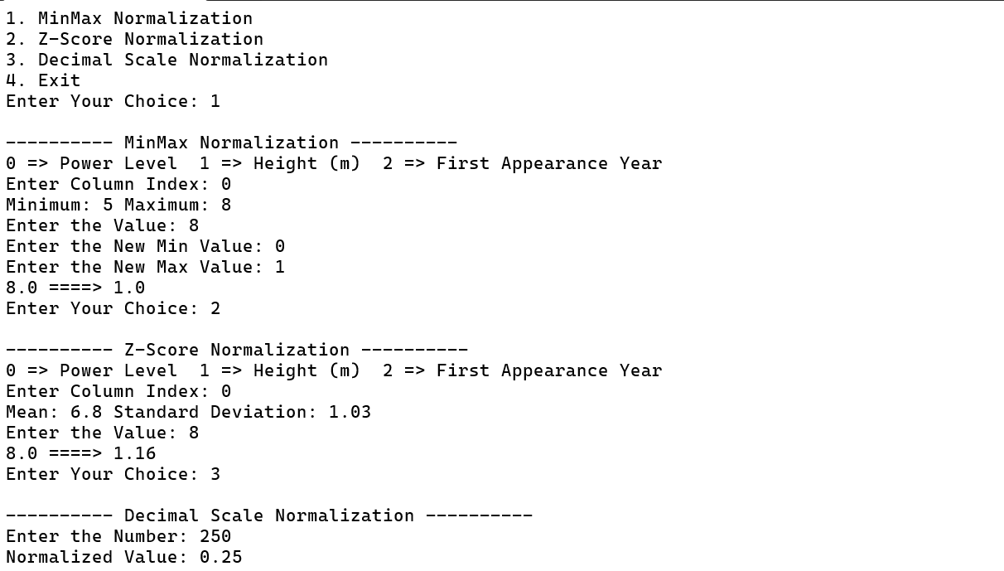

Result:
Thus, the above code is executed and the output verified successfully.
EX. No: 12
Perform feature selection using Extra Trees Classifier
Date: 10.08.2026
Aim:
To write a Python program to perform feature selection using the Extra Trees Classifier algorithm.
Code:
import pandas as pd
import matplotlib.pyplot as plt
from sklearn.datasets import load_iris
from sklearn.ensemble import ExtraTreesClassifier
iris = load_iris()
X = pd.DataFrame(iris.data, columns=iris.feature_names)
y = iris.target
model = ExtraTreesClassifier(n_estimators=100, random_state=42)
model.fit(X, y)
importance = model.feature_importances_
feature_importance = pd.DataFrame({
"Feature": X.columns,
"Importance": importance
})
feature_importance = feature_importance.sort_values(
by="Importance",
ascending=False
)
print("\n1. Display Dataset\n2. Feature Importance\n3. Plot Feature Importance\n4. Predict Iris Species\n0. Exit")
while True:
try:
ch = int(input("Enter Your Choice: "))
match ch:
case 1:
print("\n---------- Iris Dataset ----------")
print(X.head(10))
print("\nTarget Species:")
print(iris.target_names)
case 2:
print("\n---------- Feature Importance ----------")
print(feature_importance)
case 3:
print("\n---------- Feature Importance Graph ----------")
plt.figure(figsize=(8, 5))
plt.bar(
feature_importance["Feature"],
feature_importance["Importance"]
)
plt.xticks(rotation=45)
plt.xlabel("Features")
plt.ylabel("Importance")
plt.title("Feature Selection using Extra Trees Classifier")
plt.tight_layout()
plt.show()
case 4:
print("\n---------- Predict Iris Species ----------")
sl = float(input("Enter Sepal Length (cm): "))
sw = float(input("Enter Sepal Width (cm): "))
pl = float(input("Enter Petal Length (cm): "))
pw = float(input("Enter Petal Width (cm): "))
new_data = pd.DataFrame(
[[sl, sw, pl, pw]],
columns=iris.feature_names
)
prediction = model.predict(new_data)
print("Predicted Iris Species:", iris.target_names[prediction[0]])
case 0:
print("Program terminated.")
break
case _:
print("Invalid Choice!")
except Exception as e:
print("Error:", e)
Output:
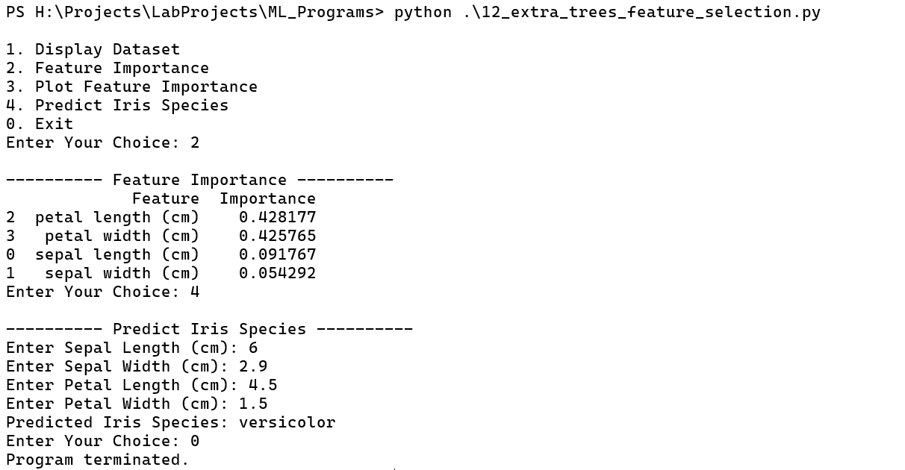
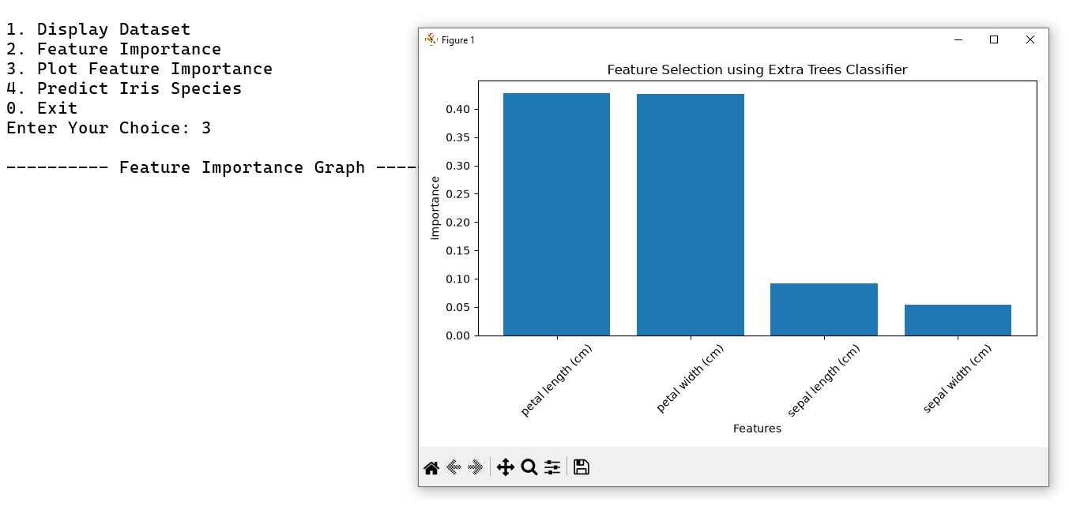

Result:
Thus, the above code is executed and the output verified successfully.
EX. No: 13
Analyze the dataset using Julius AI
Date: 17.08.2026
Aim:
To analyze a given dataset using Julius AI and interpret the results.
Steps:
Step 1: Open Julius AI
Open Google Chrome, visit https://julius.ai/, and sign up or log in to your account.
Step 2: Upload the Dataset
Open a new chat or data-analysis workspace and upload Supernatural_Series_Characters.csv.
Step 3: Understand the Dataset
Enter the following prompt:
Analyze the uploaded dataset and display the number of rows, columns, column names, data types, first five rows, and missing values in each column.
Step 4: Perform Statistical Analysis
Enter the following prompt:
Calculate the mean, median, mode, minimum, maximum, variance, and standard deviation for the numerical columns, especially First Appearance Year and Power Rating.
Step 5: Create Visualizations
Enter the following prompt:
Generate a bar chart showing the number of characters by series, a pie chart showing species distribution, a histogram of character power ratings, a box plot of power ratings by series, and a scatter plot of First Appearance Year versus Power Rating.
Step 6: Analyze Patterns and Relationships
Enter the following prompt:
Calculate the correlation between First Appearance Year and Power Rating. Identify the highest and lowest power ratings, missing values, possible outliers, and five important findings from the dataset.
Step 7: Clean and Export the Dataset
Enter the following prompt:
Check for duplicate rows, handle missing values appropriately, identify possible outliers, and create a cleaned dataset without modifying the original. Export the cleaned dataset as a CSV file if supported.
Step 8: Generate the Final Report
Enter the following prompt:
Prepare a dataset analysis report containing dataset information, statistical analysis, missing values, visualizations, correlation analysis, key findings, and a conclusion. Use the actual uploaded data and do not treat the sample power ratings as official rankings.
Step 9: Review and Download
Review the analysis and download the report, charts, or cleaned dataset using the available export options.
Output:
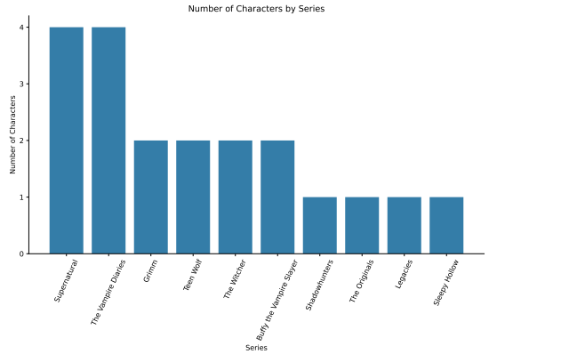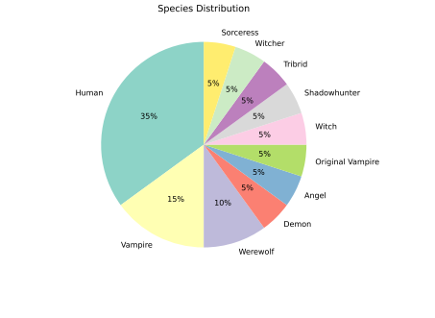

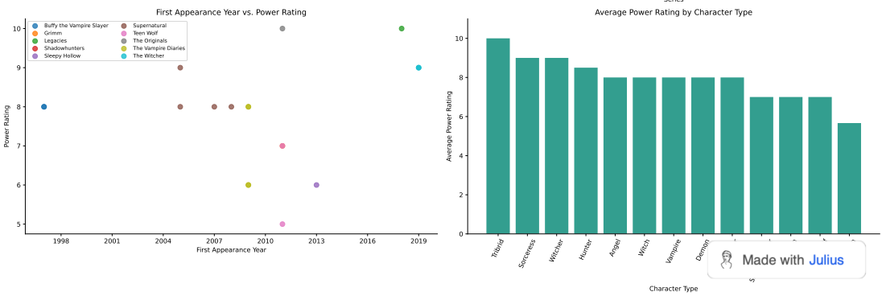

Result:
Thus, the dataset is analyzed successfully using Julius AI, and the results are verified.
EX. No: 14
Analyze the dataset with dashboard using Bricks AI
Date: 22.08.2026
Aim:
To analyze a given dataset and create an interactive dashboard using Bricks AI.
Steps:
Step 1: Open Bricks AI
Open Google Chrome, visit https://www.thebricks.com/, and sign up or log in to your account.
Step 2: Create a New Project
Open a new workspace or create a new project in Bricks AI.
Step 3: Upload the Dataset
Upload the billing and payment dataset in CSV or Excel format, or import it from a supported spreadsheet source.
Step 4: Analyze the Dataset
Enter the following prompt:
Analyze the uploaded dataset. Display the number of rows, columns, column names, data types, and a summary of the billing and payment data.
Step 5: Perform Statistical Analysis
Enter the following prompt:
Analyze the 2026 billing and payment data. Calculate total sales, total payments, average bill value, customer counts, payment-mode distribution, and other relevant billing KPIs.
Step 6: Create the Dashboard
Enter the following prompt:
Create an interactive dashboard using the uploaded dataset. Include KPI cards, total records, billing and payment summaries, daily revenue trends, top customers and vehicles, payment-mode distribution, collection timing, underpayments, and advance usage.
Step 7: Add Charts and Filters
Enter the following prompt:
Create suitable charts to show daily revenue trends, top customers and vehicles, payment-mode distribution, and billing versus payment activity. Add suitable filters or slicers where supported.
Step 8: Identify Important Insights
Enter the following prompt:
Explain the important insights from the dashboard in simple English. Identify sales trends, customer concentration, highest and lowest values, collection delays, underpayments, advance usage, outliers, and data quality issues where the dataset supports these findings.
Step 9: Customize and Verify the Dashboard
Review the dashboard and adjust the layout, chart types, titles, labels, and formatting. Verify that the calculations and visualizations correctly represent the uploaded data.
Step 10: Save and Export the Dashboard
Save the dashboard and export or share it using the available options in Bricks AI.

Output:
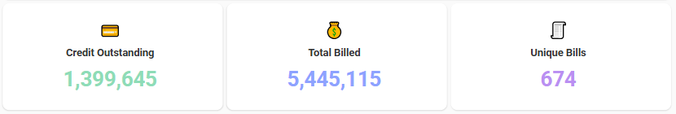
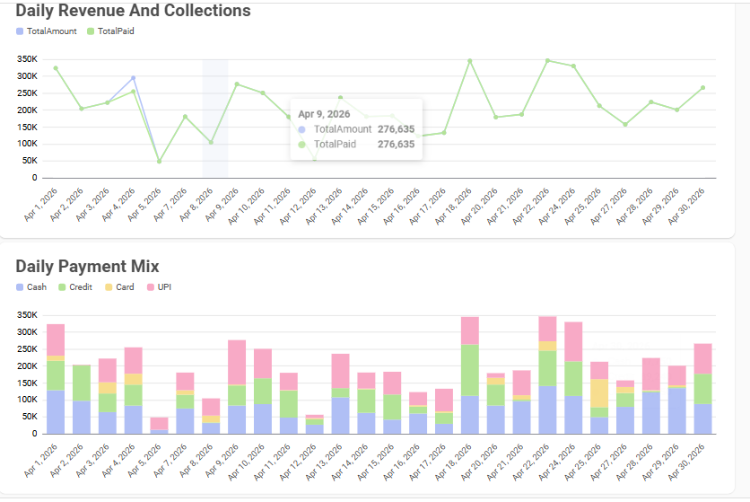

Result:
Thus, the dataset is analyzed and the dashboard is created successfully using Bricks AI.
EX. No: 15
Perform feature extraction using Principal Component Analysis
Date: 27.08.2026
Aim:
To write a Python program to perform feature extraction using Principal Component Analysis (PCA).
Code:
import numpy as np
import matplotlib.pyplot as plt
from sklearn.datasets import load_iris
from sklearn.preprocessing import StandardScaler
from sklearn.decomposition import PCA
iris = load_iris()
X = iris.data
y = iris.target
print("Feature Names:")
print(iris.feature_names)
print("\nDataset Shape:", X.shape)
scaler = StandardScaler()
X_scaled = scaler.fit_transform(X)
pca = PCA(n_components=2)
X_pca = pca.fit_transform(X_scaled)
print("\nExplained Variance Ratio:")
print(pca.explained_variance_ratio_)
print("\nTotal Variance Explained:",
sum(pca.explained_variance_ratio_))
print("\nFirst 5 PCA-transformed samples:")
print(X_pca[:5])
plt.figure(figsize=(8, 6))
for i, target_name in enumerate(iris.target_names):
plt.scatter(
X_pca[y == i, 0],
X_pca[y == i, 1],
label=target_name
)
plt.xlabel("Principal Component 1")
plt.ylabel("Principal Component 2")
plt.title("PCA of Iris Dataset")
plt.legend()
plt.grid()
plt.show()
Output:
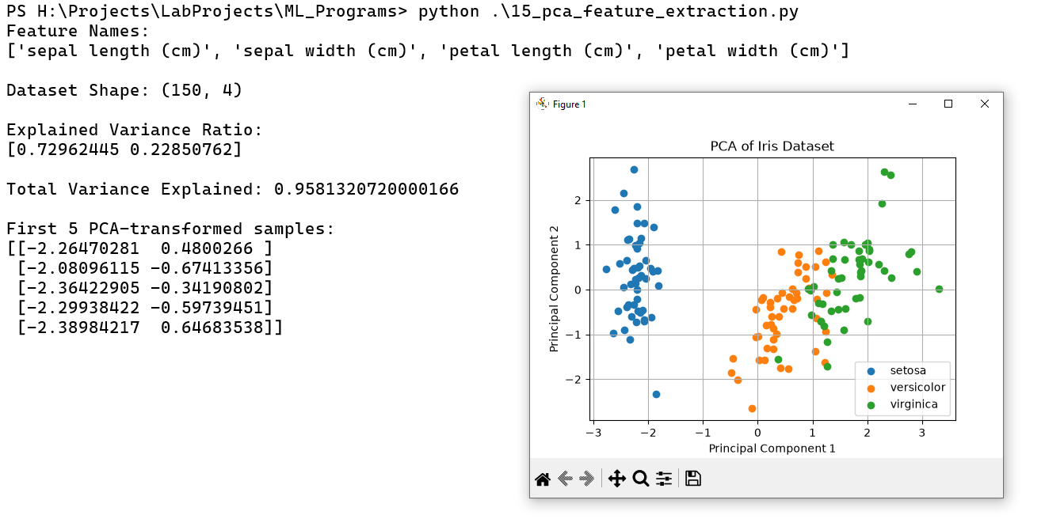

Result:
Thus, the above code is executed and the output verified successfully.
EX. No: 16
Implement KNN classification algorithm for an iris dataset using scikit-learn
Date: 01.09.2026
Aim:
To write a Python program to classify the Iris dataset using the K-Nearest Neighbors (KNN) algorithm with scikit-learn.
Code:
from sklearn.datasets import load_iris
from sklearn.neighbors import KNeighborsClassifier
from sklearn.model_selection import train_test_split
irisData = load_iris()
x = irisData.data
y = irisData.target
x_train, x_test, y_train, y_test = train_test_split(
x, y, test_size=0.2, random_state=30
)
knn = KNeighborsClassifier(n_neighbors=7)
knn.fit(x_train, y_train)
print("Iris Dataset Loaded Successfully")
print("Model Accuracy:", knn.score(x_test, y_test))
s1 = float(input("Enter sepal length: "))
s2 = float(input("Enter sepal width: "))
s3 = float(input("Enter petal length: "))
s4 = float(input("Enter petal width: "))
user_pre = knn.predict([[s1, s2, s3, s4]])
flower = irisData.target_names[user_pre[0]]
print("\nPredicted Flower Name:", flower)
print("\nPredictions on Test Data:")
print(knn.predict(x_test))

Output:
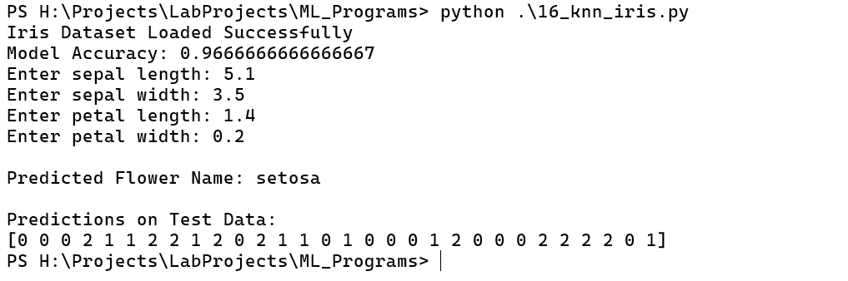

Result:
Thus, the above code is executed and the output verified successfully.
EX. No: 17
Home Price Prediction using Linear Regression for error based learning
Date: 07.09.2026
Aim:
To write a Python program to predict house prices using Linear Regression and evaluate the prediction error.
Code:
import pandas as pd
import matplotlib.pyplot as plt
from sklearn import linear_model
from sklearn.model_selection import train_test_split
from sklearn.metrics import mean_squared_error, r2_score
# Create a local dataset
df = pd.DataFrame({
'area': [1000, 1200, 1500, 1800, 2000,
2200, 2500, 2800, 3000, 3200,
3500, 3800, 4000, 4200, 4500,
4800, 5000, 5200, 5500, 6000],
'price': [150000, 180000, 225000, 270000, 300000,
330000, 375000, 420000, 450000, 480000,
525000, 570000, 600000, 630000, 675000,
720000, 750000, 780000, 825000, 900000]
})
print("Home Price Dataset:")
print(df.head(5))
X = df[['area']]
y = df['price']
X_train, X_test, y_train, y_test = train_test_split(
X, y, test_size=0.2, random_state=42
)
reg = linear_model.LinearRegression()
reg.fit(X_train, y_train)
y_pred = reg.predict(X_test)
print("\nTraining samples:", len(X_train))
print("Testing samples:", len(X_test))
print("R2 score:", r2_score(y_test, y_pred))
print("Mean Squared Error:", mean_squared_error(y_test, y_pred))
# Plot 1: Regression Line
reg.fit(X, y)
plt.figure(figsize=(8, 5))
plt.scatter(df['area'], df['price'], color='green',
marker='D', label='Actual Prices')
plt.plot(df['area'], reg.predict(X), color='red',
label='Regression Line')
plt.title('Home Price Prediction using Linear Regression')
plt.xlabel('Area')
plt.ylabel('Price')
plt.legend()
plt.grid()
plt.show()
# Plot 2: Prediction Errors
errors = y_test - y_pred
plt.figure(figsize=(8, 5))
plt.scatter(y_pred, errors, color='purple')
plt.axhline(y=0, color='red', linestyle='--')
plt.title('Prediction Errors')
plt.xlabel('Predicted Price')
plt.ylabel('Error')
plt.grid()
plt.show()
# Predict prices for new areas
area_df = pd.DataFrame({
'area': [1000, 1600, 2100, 3300, 5000, 6500]
})
area_df['prices'] = reg.predict(area_df[['area']])
print("\nPredicted Home Prices:")
print(area_df)

Output:
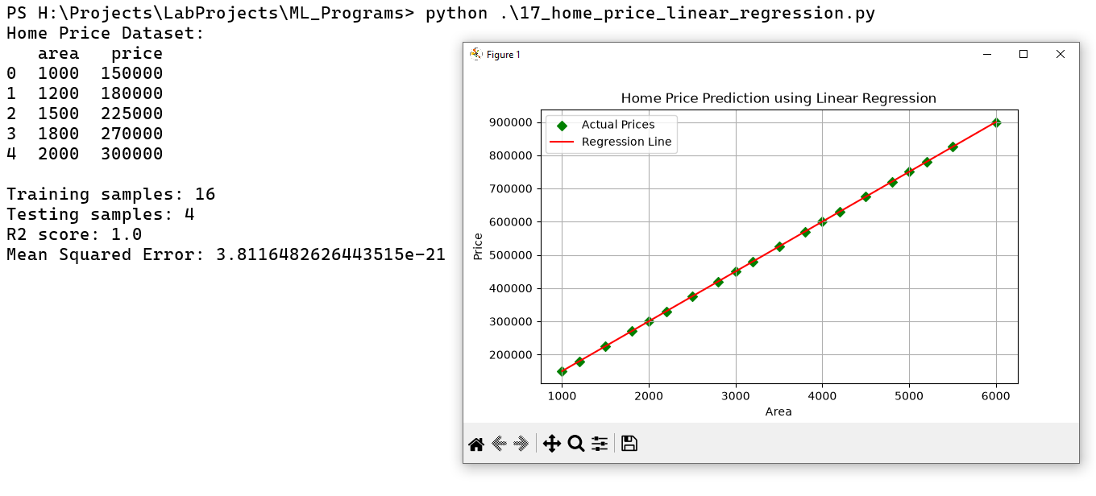
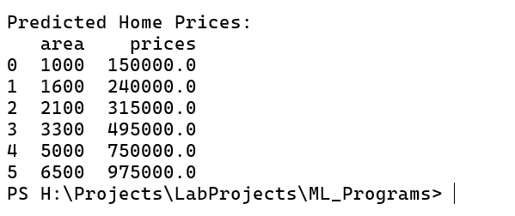

Result:
Thus, the above code is executed and the output verified successfully.
EX. No: 18
Perform SVM Classification using scikit-learn
Date: 10.09.2026
Aim:
To write a Python program to perform classification using the Support Vector Machine (SVM) algorithm with scikit-learn.
Code:
import pandas as pd
import numpy as np
import matplotlib.pyplot as plt
import seaborn as sns
from sklearn.model_selection import train_test_split
from sklearn.preprocessing import StandardScaler
from sklearn.svm import SVC
from sklearn.metrics import (accuracy_score, confusion_matrix,
classification_report, ConfusionMatrixDisplay)
# Load your local dataset
df = pd.read_csv("datasets/breast_cancer_dataset.csv")
print("Dataset shape:", df.shape)
print(df['diagnosis_label'].value_counts())
X = df.drop(columns=['diagnosis', 'diagnosis_label'])
y = df['diagnosis']
X_train, X_test, y_train, y_test = train_test_split(
X, y, test_size=0.2, random_state=42, stratify=y
)
scaler = StandardScaler()
X_train_scaled = scaler.fit_transform(X_train)
X_test_scaled = scaler.transform(X_test)
svm_model = SVC(kernel='rbf', C=1.0, gamma='scale', random_state=42)
svm_model.fit(X_train_scaled, y_train)
y_pred = svm_model.predict(X_test_scaled)
acc = accuracy_score(y_test, y_pred)
print(f"\nAccuracy: {acc*100:.2f}%")
print("\nClassification Report:\n", classification_report(
y_test, y_pred, target_names=['malignant', 'benign']))
cm = confusion_matrix(y_test, y_pred)
disp = ConfusionMatrixDisplay(
confusion_matrix=cm, display_labels=['malignant', 'benign'])
disp.plot(cmap='Blues')
plt.title("SVM - Confusion Matrix (Breast Cancer Diagnosis)")
plt.tight_layout()
plt.savefig("svm_confusion_matrix.png", dpi=150)
plt.show()
svm_linear = SVC(kernel='linear', C=1.0, random_state=42)
svm_linear.fit(X_train_scaled, y_train)
acc_linear = accuracy_score(y_test, svm_linear.predict(X_test_scaled))
print(f"\nLinear kernel accuracy: {acc_linear*100:.2f}%")
print(f"RBF kernel accuracy : {acc*100:.2f}%")
Output:
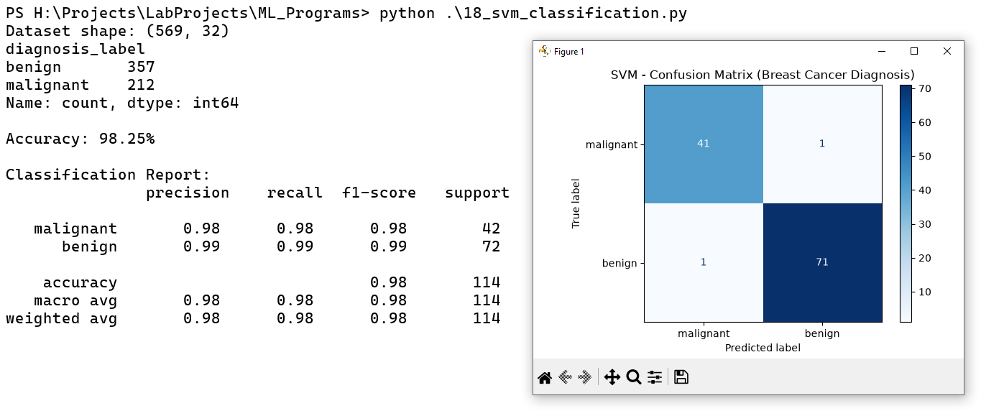

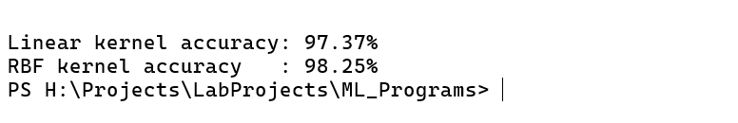

Result:
Thus, the above code is executed and the output verified successfully.

EX. No: 19
Implement Decision tree algorithm for an elective dataset
Date: 15.09.2026
Aim:
To write a Python program to implement the Decision Tree classification algorithm on a given dataset.
Code:
import pandas as pd
from sklearn.tree import DecisionTreeClassifier, plot_tree, export_text
from sklearn.model_selection import train_test_split
from sklearn.metrics import accuracy_score, confusion_matrix, classification_report
import matplotlib.pyplot as plt
# Load the given dataset
df = pd.read_ex("datasets/elective_dataset.xlsx")
X = df[["GENDER", "UG", "Cross Major"]]
y = df["ELECTIVE"]
X = pd.get_dummies(X, dtype=int)
print("\nEncoded Features:")
print(X)
feature_names = X.columns.tolist()
X_train, X_test, y_train, y_test = train_test_split(
X, y,
test_size=0.5,
random_state=42,
stratify=y
)
clf = DecisionTreeClassifier(
criterion="gini",
random_state=42
)
clf.fit(X_train, y_train)
y_pred = clf.predict(X_test)
acc = accuracy_score(y_test, y_pred)
print(f"Test Accuracy: {acc:.4f}")
print(classification_report(y_test, y_pred))
print("Confusion Matrix:")
print(confusion_matrix(y_test, y_pred))
print("TEXT REPRESENTATION OF DECISION TREE")
print(export_text(
clf,
feature_names=feature_names
))
plt.figure(figsize=(15, 8))
plot_tree(
clf,
feature_names=feature_names,
class_names=[str(c) for c in clf.classes_],
filled=True,
rounded=True
)
plt.title("Decision Tree - Elective Prediction")
plt.show()
Output:
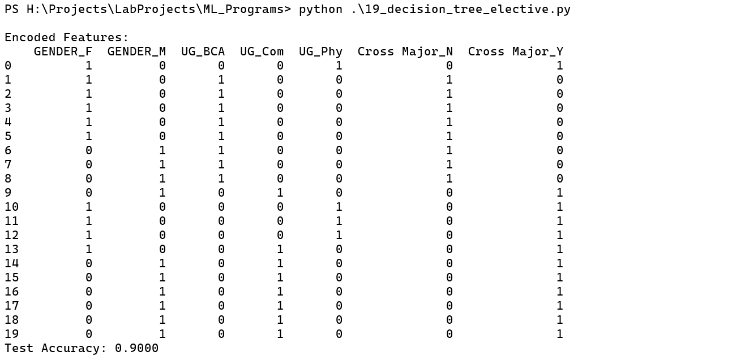
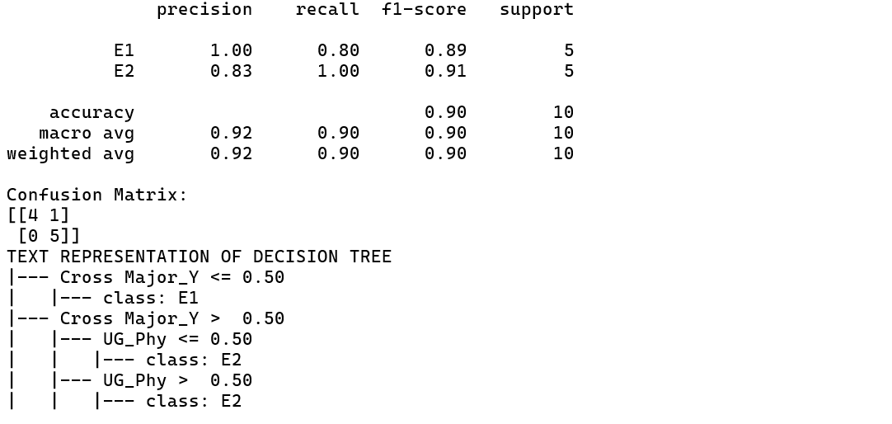
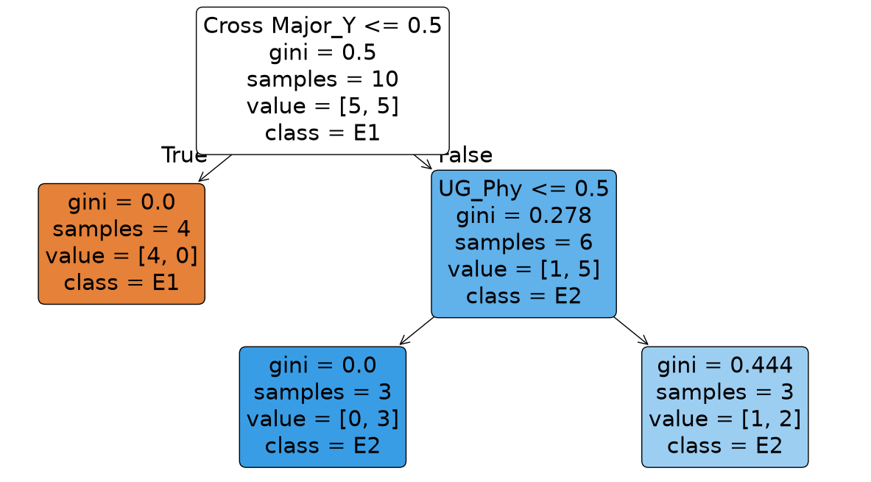

Result:
Thus, the above code is executed and the output verified successfully.
EX. No: 20
Implement Random forest algorithm with customer churn dataset
Date: 19.09.2026
Aim:
To write a Python program to predict customer churn using the Random Forest classification algorithm.
Code:
import pandas as pd
import matplotlib.pyplot as plt
from sklearn.model_selection import train_test_split
from sklearn.preprocessing import LabelEncoder
from sklearn.ensemble import RandomForestClassifier
from sklearn.metrics import (accuracy_score, confusion_matrix,
classification_report, ConfusionMatrixDisplay)
df = pd.read_csv("datasets/customer_churn_dataset.csv")
print("Dataset shape:", df.shape)
print(df['Churn'].value_counts())
df['TotalCharges'] = pd.to_numeric(df['TotalCharges'], errors='coerce')
df['TotalCharges'] = df['TotalCharges'].fillna(df['TotalCharges'].median())
df = df.drop(columns=['customerID'])
for col in df.select_dtypes(include=['object', 'str']).columns:
le = LabelEncoder()
df[col] = le.fit_transform(df[col])
X = df.drop(columns=['Churn'])
y = df['Churn']
X_train, X_test, y_train, y_test = train_test_split(
X, y, test_size=0.2, random_state=42, stratify=y
)
rf_model = RandomForestClassifier(
n_estimators=200,
max_depth=8,
random_state=42,
n_jobs=-1
)
rf_model.fit(X_train, y_train)
y_pred = rf_model.predict(X_test)
acc = accuracy_score(y_test, y_pred)
print(f"\nAccuracy: {acc*100:.2f}%")
print("\nClassification Report:\n",
classification_report(y_test, y_pred))
cm = confusion_matrix(y_test, y_pred)
disp = ConfusionMatrixDisplay(confusion_matrix=cm)
disp.plot(cmap='Greens')
plt.title("Random Forest - Confusion Matrix")
plt.tight_layout()
plt.show()
importances = pd.Series(
rf_model.feature_importances_, index=X.columns
).sort_values(ascending=False).head(10)
plt.figure(figsize=(8, 5))
importances.plot(kind='barh')
plt.gca().invert_yaxis()
plt.title("Top 10 Features Influencing Customer Churn")
plt.xlabel("Importance Score")
plt.tight_layout()
plt.show()
Output:
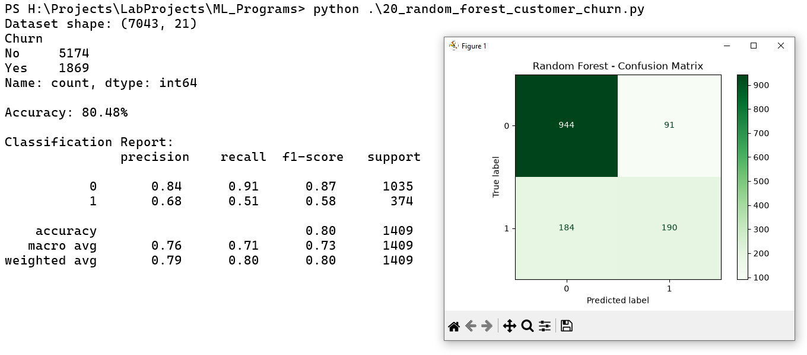
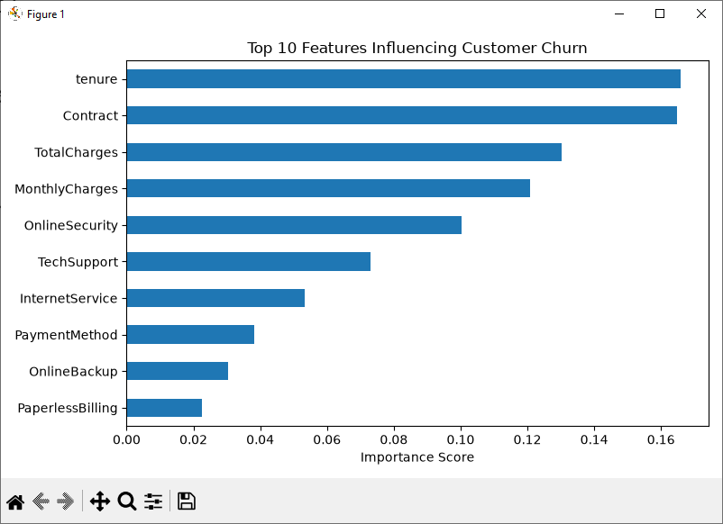

Result:
Thus, the above code is executed and the output verified successfully.
EX. No: 21
Perform Naïve Bayes Classification for loan dataset using scikit-learn
Date: 22.09.2026
Aim:
To write a Python program to perform loan approval classification using the Naïve Bayes algorithm with scikit-learn.
Code:
import pandas as pd
import seaborn as sns
import matplotlib.pyplot as plt
df = pd.read_csv('datasets/loan.csv')
print(df.head())
df.info()
sns.countplot(data=df, x='purpose', hue='not.fully.paid')
plt.xticks(rotation=45, ha='right')
plt.title("Loan Purpose vs Payment Status")
plt.tight_layout()
plt.show()
pre_df = pd.get_dummies(df, columns=['purpose'], drop_first=True)
print(pre_df.head())
from sklearn.model_selection import train_test_split
X = pre_df.drop('not.fully.paid', axis=1)
y = pre_df['not.fully.paid']
print(X)
print(y)
X_train, X_test, y_train, y_test = train_test_split(
X, y, test_size=0.33, random_state=125
)
from sklearn.naive_bayes import GaussianNB
model = GaussianNB()
model.fit(X_train, y_train)
from sklearn.metrics import (
accuracy_score,
confusion_matrix,
ConfusionMatrixDisplay,
f1_score,
classification_report,
)
y_pred = model.predict(X_test)
accuracy = accuracy_score(y_test, y_pred)
f1 = f1_score(y_test, y_pred, average="weighted")
print("\nAccuracy:", accuracy)
print("F1 Score:", f1)
print("\nClassification Report:")
print(classification_report(y_test, y_pred, zero_division=0))
cm = confusion_matrix(y_test, y_pred)
disp = ConfusionMatrixDisplay(confusion_matrix=cm)
disp.plot(cmap='Blues')
plt.title("Naive Bayes - Confusion Matrix")
plt.tight_layout()
plt.show()
Output:
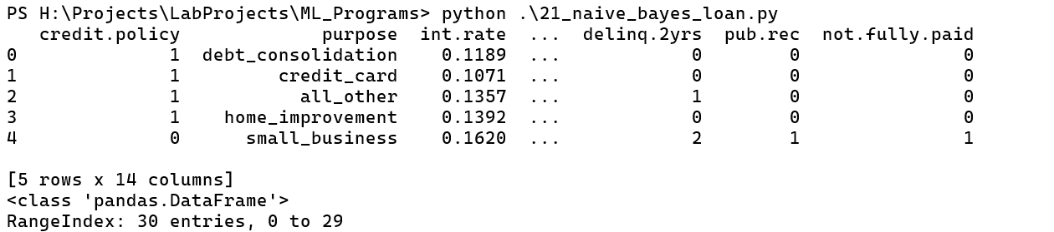
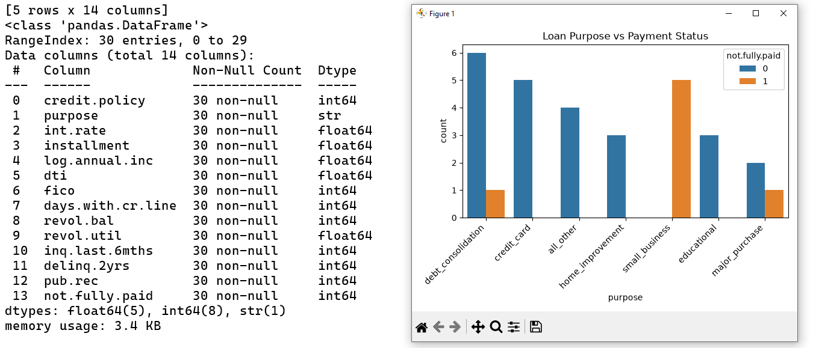
Result:
Thus, the above code is executed and the output verified successfully.
EX. No: 22
Customer Segmentation based on Annual Income using K-means algorithm
Date: 28.09.2026
Aim:
To write a Python program to perform customer segmentation based on annual income using the K-means clustering algorithm.
Code:
import numpy as np
import pandas as pd
import matplotlib.pyplot as plt
import seaborn as sns
import warnings
warnings.filterwarnings('ignore')
customer_data = pd.read_csv("datasets/Mall_Customers.csv")
customer_data.head(25)
customer_data.shape
customer_data.info()
customer_data.isnull().sum()
X = customer_data.iloc[:,[3,4]].values
X[:25]
from sklearn.cluster import KMeans
wcss = []
for i in range(1,11):
kmeans = KMeans(n_clusters=i, init = 'k-means++', random_state = 42)
kmeans.fit(X)
wcss.append(kmeans.inertia_)
plt.plot(range(1,11), wcss)
plt.title('The Elbow Point Graph')
plt.xlabel('Number of Clusters')
plt.ylabel('WCSS')
plt.show()
kmeans = KMeans(n_clusters=5,init='k-means++',random_state=42)
y = kmeans.fit_predict(X)
print(y)
plt.figure(figsize=(6,6))
plt.scatter(X[y==0,0], X[y==0,1], s=50, c='green', label='Cluster 1')
plt.scatter(X[y==1,0], X[y==1,1], s=50, c='blue', label='Cluster 2')
plt.scatter(X[y==2,0], X[y==2,1], s=50, c='yellow', label='Cluster 3')
plt.scatter(X[y==3,0], X[y==3,1], s=50, c='red', label='Cluster 4')
plt.scatter(X[y==4,0], X[y==4,1], s=50, c='violet', label='Cluster 5')
plt.scatter(kmeans.cluster_centers_[:,0], kmeans.cluster_centers_[:,1], s=50, c='black', label='Centroids')
plt.title('Customer Groups')
plt.xlabel('Annual Income')
plt.ylabel('Spending Score')
plt.show()
Output:
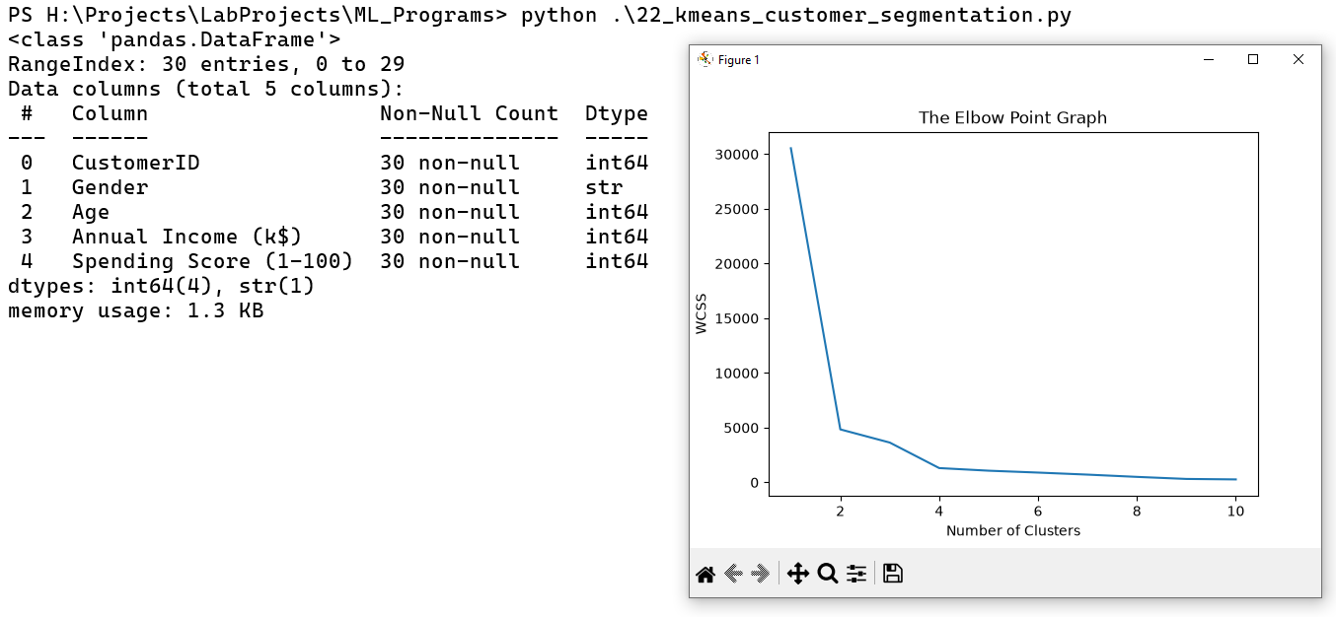
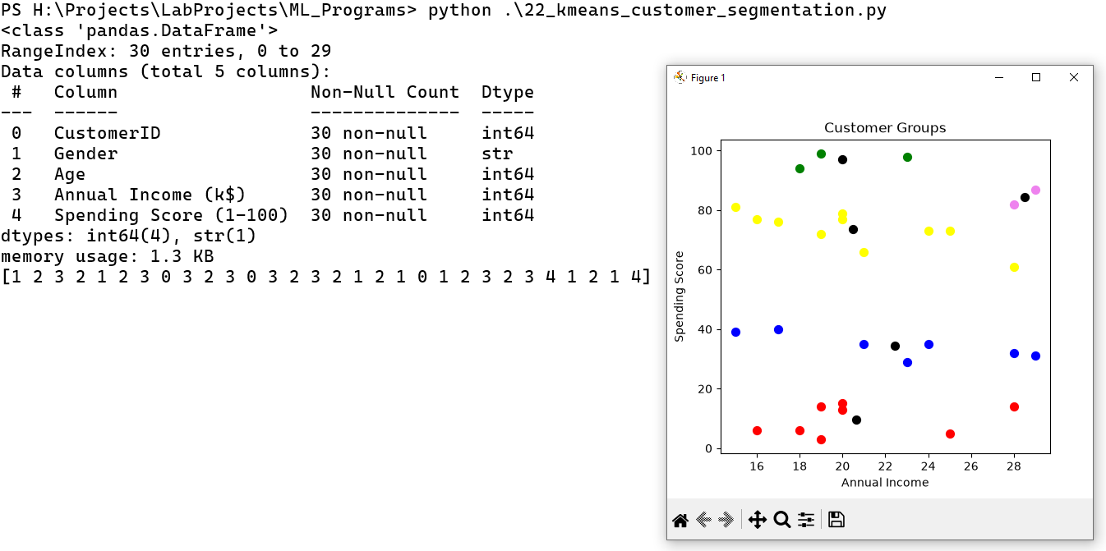
Result:
Thus, the above code is executed and the output verified successfully.
EX. No: 23
Perform E-mail Classification using Levity
Date: 01.10.2026
Aim:
To classify emails into appropriate categories using the Levity AI platform.
Steps:
Step 1: Open Google Chrome on your computer.
Step 2: Visit the official website: https://levity.ai/
Step 3: Sign up or log in to Levity AI.
Step 4: Create a new AI workflow or classification project.
Step 5: Select the Text Classification option or a similar text-processing workflow, if available.
Step 6: Enter the project name as Email Classification.
Step 7: Prepare a dataset containing email messages and their corresponding categories.
Step 8: Create classification labels such as Spam and Not Spam.
Step 9: Upload the email dataset in a supported format, such as CSV, if supported.
Step 10: Map the email message column to the input field and the category column to the classification label.
Step 11: Review the dataset to ensure that the email messages and labels are correct.
Step 12: Train the AI model using the labeled email examples.
Step 13: Wait until the model training process is completed.
Step 14: Test the trained model using new email messages that were not included in the training dataset.
Step 15: Check whether the model correctly classifies each email as Spam or Not Spam.
Step 16: Review the model's performance and add more labeled examples if necessary.
Step 17: Configure an automated workflow to classify incoming emails, if email integration is supported by the available plan.
Step 18: Save the project and review the final classification results.

Output:

Result:
Thus, the email classification model is implemented and tested successfully using Levity AI.
EX. No: 24
Implementation of image classification using Teachable Machine
Date: 06.10.2026
Aim:
To build and test an image classification model using Google's Teachable Machine.
Steps:
Step 1: Open google chrome to search teachable machine.
Step 2: Select the first link in the browser.

Step 3: Teachable machine website is open and click the Get Started button to start design the model.
Step 4: Choose the image project. There are two options, standard and embedded then choose standard.


Step 5: After clicking on Standard Image Project, classes will be added to classify with the help of the model.
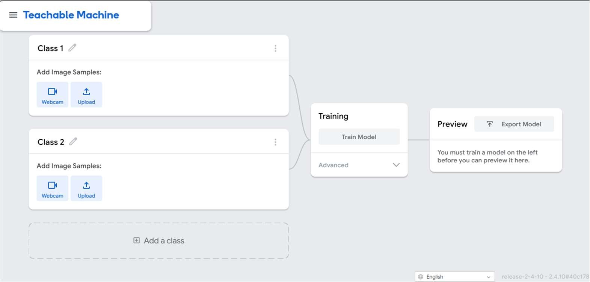
Step 6: Now, create classes and start uploading the images. Replace class1 as Car, class2 name as Bike and add another class3 name as Truck.
Step 7: Upload images from the dataset or use the live camera to capture the images.
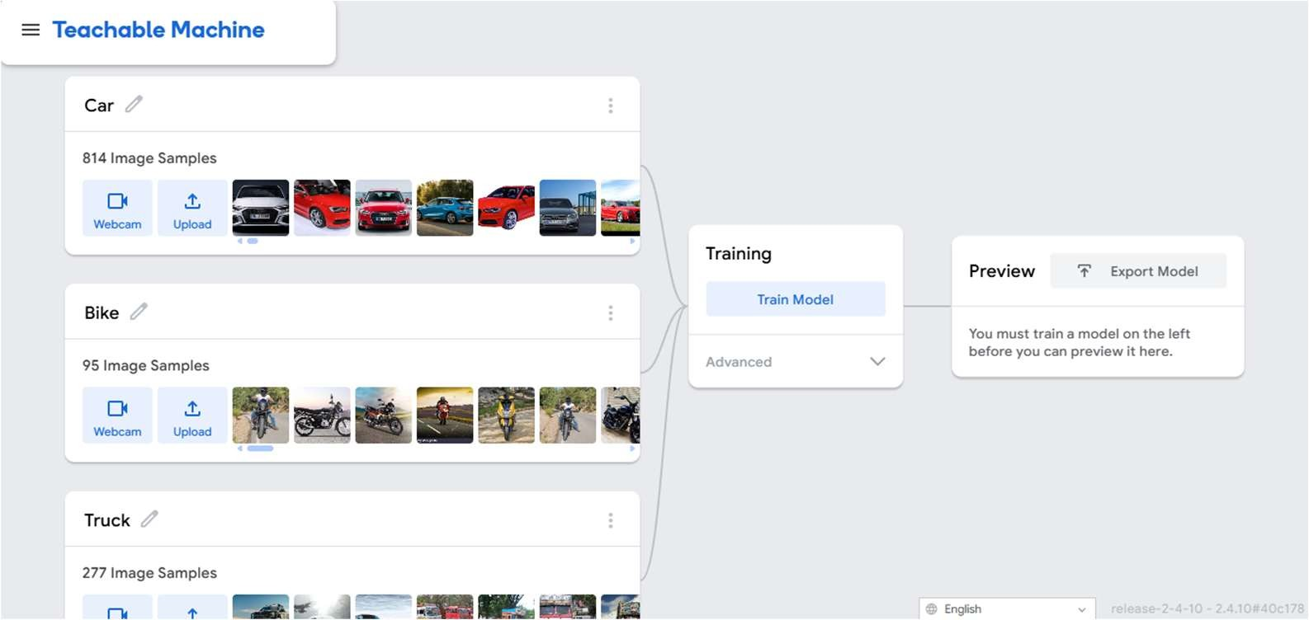
Step 8: After uploading the images, click on Train Model.


Step 9: Test the model by using the unseen dataset.
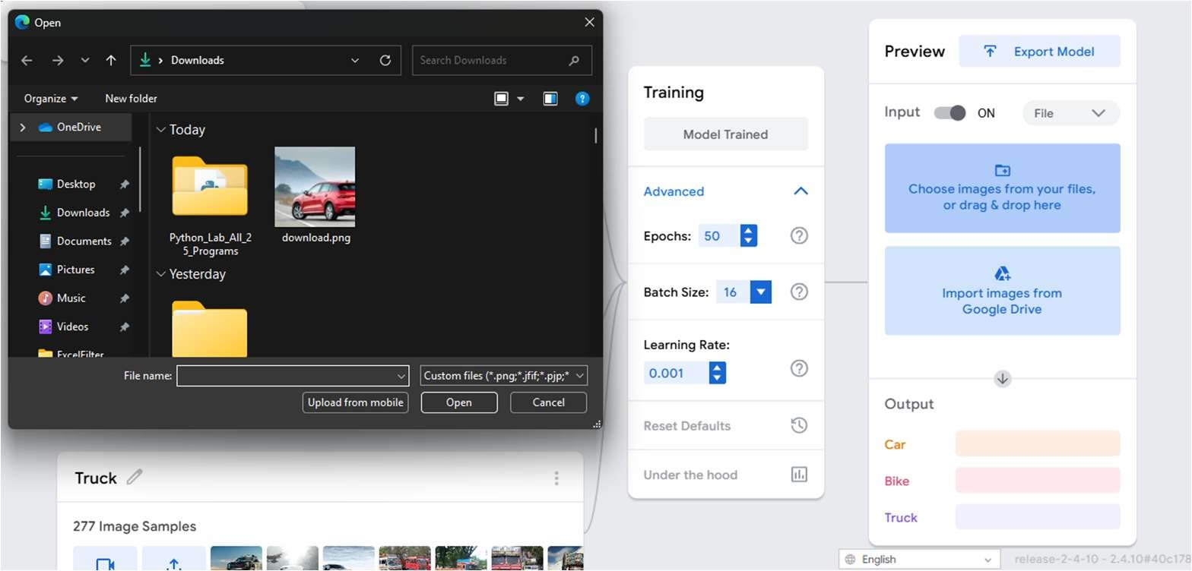
Step 10: After train and test the model, it’s time to export the model. Click the uploaded my model and get the link, copy the link.

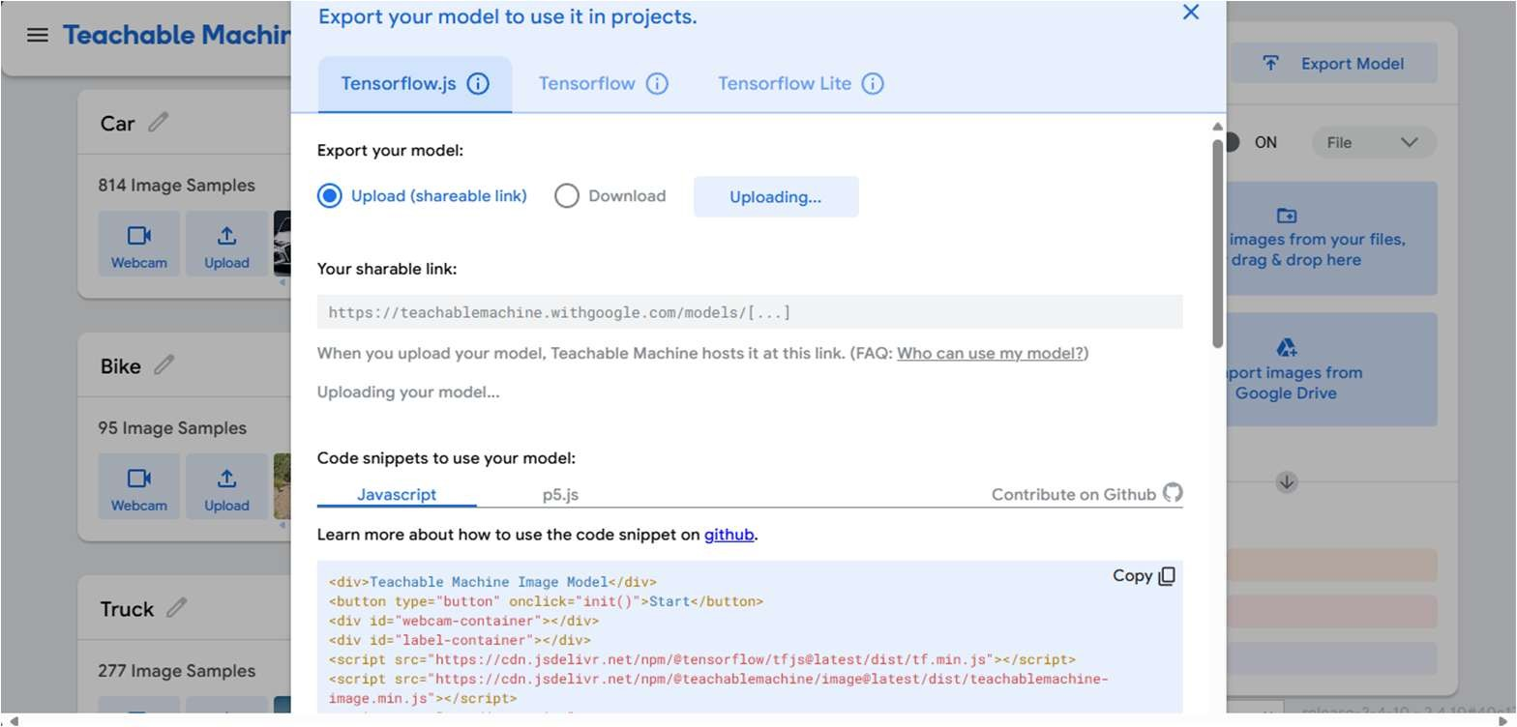
Step 11: https://teachablemachine.withgoogle.com/models/QLrTRFoCz/ paste the link in new tab.

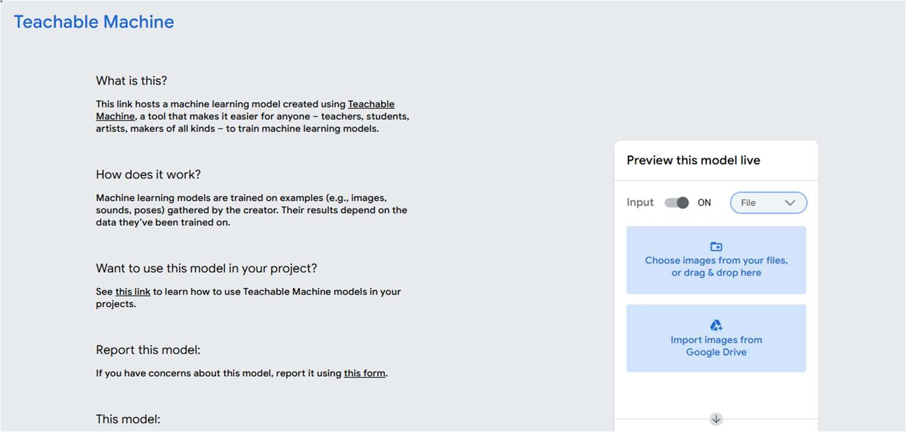

Output:



Result:
Thus, the image classification model is trained and tested successfully using Teachable Machine.

